LAGOS CITY POLYTECHNIC
LECTURE NOTE
COURSE TITLE: TELECOMMUNICATION ENGINEERING II
COURSE CODE: EEC 238/244, FOR: ND 2 (EE & CE)
LECTURER/INSTRUCTOR: ENGR. A. OJO-WILLIAMS,
CONTENTS
Chapter One: BASIC PRINCIPLES OF TELECOMMUNICATION SYSTEM

Chapter Two: PRINCIPLES AND APPLICATIONS OF VARIOUS TRANSDUCERS
Chapter Three :
- MODULATION & DEMODULATION
- AMPLITUDE MODULATION
- FREQUENCY MODULATION
Chapter Four:
- RADIO TRANSMISSION
- BLACK & WHITE TELEVISION TRANSMISSION
- COLOUR TELEVISION TRANSMISSION
Chapter Five :
- RADIO RECEPTION
- BLACK & WHITE TELEVISION RECEPTION
- COLOUR TELEVISION RECEPTION

Chapter Six: TELEPHONE & TELEGRAPHY
Chapter Seven : CLASSIFICATIONS OF RADIO FREQUENCIES
Chapter Eight: ANTENNAS
Chapter Nine: PROPAGATION OF RADIO WAVES

CHAPTER 1.0
BASIC PRINCIPLES OF TELECOMMUNICATION SYSTEM

With advancements of every society regarding educational, business, manufacturing, computing,
agricultural sectors etc, there became an intense desire for individuals (humans), as well as objects to communicate with other individuals such relatives, friends, associates, etc across the
globe. Interactions such as such Human to human (H2H), Machine to Machine (M2M), or even
human to machine (H2M) usually involves communication. The science of communication involving long distances is called Telecommunication derived from the word “tele”, meaning
long distance.

Telecommunication is the transmission of signs, signals, messages, words, writings, images and sounds (or intelligence) of any nature by wire, radio, optical or other electromagnetic systems over a distance.

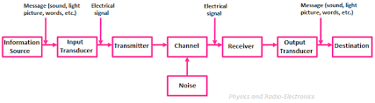
Figure 1.i: Block Diagram of a communication system

FUNCTIONS OF THE BLOCK DIAGRAMS ABOVE

- Information Source: the message to be communicated originates in the information source. There can be various messages in the form of words, group of words, code, symbols, sound signal etc. out of all these messages, only the desired message is selected and communicated. Therefore the function of the information source is to produced required message which has to be transmitted.
- Input Transducer: a transducer is a device which converts one forma of energy into another form. In a case where the message produced by the information source is not electrical in nature, an input transducer is used to convert it into a time varying electrical signal
- Transmitter: the function of the transmitter is to process the message signal into a form suitable for transmission over the communication channel.
- The Channel & the noise: this is the medium through which the message travels from the transmitter to the receiver. There are two types of channels: point-to-point and broadcast channel. Examples of point-to-point channels are wire lines, microwave links and optical fibers. Broadcast channel provides a capacity where several receiving stations can be reached simultaneously from a single transmitter. An example of the broadcast channel is a satellite in geostationary orbit, which covers about one-third of the earth’ surface.
- Receiver: this reproduces the message signal in electrical form from the distorted received signal through the process known as demodulation or detection.
- Output Transducer: this is the conversion of electrical message signal into its original form. For example, in radion broadcasting, the output transducer is the loudspeaker which which works by converting the electrical signal in the form of original sound signal

In technical context, communication defines transmission, reception and processing of information by electronic means. The original communication systems viz: line telegraphy was invented in the eighteen forties. But radio communication became a reality in the beginning of the 20th century with the invention of triode devices. Radio communication has evolved immensely from the 2nd world war till date. This is as a result of the explosion in the invention of transistors, integrated circuits and other semi-conductor devices. Moore’s law of transistor count still drives the electronic industries supporting telecommunication till date. In the recent years, communication has become more widespread with the use of satellites, fiber optics, and long term evolution networks (3-5Gs). Telemetry and radar systems play vital role in our military defense, navigation and even scientific research engagements.
Generally, a comprehensive learning of telecommunication systems as highlighted above will stimulate critical thinking on how to match human problems with technological solutions

Model of Communication System
To transfer information from point A to point B, another form of link is required between the
two pints. A communication system therefore specifies the totality of mechanisms that offers
the needed information link. For example, an electrical communication system could serve
this purpose being the information link. The main idea behind any communication system is
to successfully replicate the source information at the destination. As such, for successful
communication to be achieved, the message received at the destination must remain identical
to the original message evolving from the source. The different steps involved in the
transmission of information are enumerated below.

i. Origin of information in the mind of the person who wants to communicate.
ii. Generation of message signal carrying the information.
iii. Converting the message signal into electrical form using a suitable transducer.
iv. Processing the message signal such that it will have the capability to travel for a long
distance.
v. Transmission of the processed message signal to the desire destination
vi. Reception of the processed message signal at the desired destination
vii. Processing the received message signal in such a way to recreate the original nonelectrical
form
viii. Finally, delivering the inform from the message signal to the intended person

A clear understanding of the basic issues in the above steps independent of the type of
communication system will lead to comprehensive understanding of any communication
system such as telephony, radio broadcasting, television broadcasting, radar communication,
satellite communication, fiber optics communication, computer communication
ASSIGNMENT 1.0
- State two definitions of telecommunication?
- Draw another block diagram of communication system apart from the one in this section and explain the effect of noise
- Mention five modern equipments/gadgets used for communications and explain the technology involve

QUIZ 1.0
- Differentiate between transmitter and receiver
- Differentiate between input and output transducers
- State three challenges that may be encountered in telecommunication system

CHAPTER 2.0
TRANSDUCERS
A transducer is a device that converts energy from one form to another. Usually a transducer converts a signal in one form of energy to a signal in another.^{[1]}
Transducers are often employed at the boundaries of automation, measurement, and control systems, where electrical signals are converted to and from other physical quantities (energy, force, torque, light, motion, position, etc.). The process of converting one form of energy to another is known as transduction.
It is the first sensing element and is required only when measuring a non-electrical quantity, say,
temperature or pressure. Its function is to convert the non-electrical physical quantity into an electrical signal. Of course, a transducer is not required if the quantity being measured is already in the electrical form.

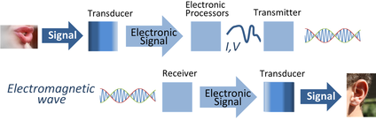
Transducers are used in electronic communications systems to convert signals of various physical forms to electronic signals, and vice versa. In this example, the first transducer could be a microphone, and the second transducer could be a speaker.

Types of Transducers
- Active Transducers
- Passive Transducers
- Bidirectional Transducers

- Active Transducers
Active transducers/ sensors generate an electric current in response to an external stimulus which serves as the output signal without the need of an additional energy source. Such examples are a photodiode, and a piezoelectric sensor, thermocouple
- Passive Transducers

Passive sensors/transducers require an external power source to operate, which is called an excitation signal. The signal is modulated by the sensor to produce an output signal. For example, a thermistor does not generate any electrical signal, but by passing an electric current through it, its resistance can be measured by detecting variations in the current or voltage across the thermistor
- Bidirectional Transducers
These convert physical phenomenal to electrical signals and also converts electrical signals into physical phenomena. Examples of inherently bidirectional transducers are antennae, which convert conducted electrical signal to or from propagating electromagnetic waves, and voice coils, which convert electrical signals into sound (when used in a loudspeaker) or sound into electrical signals (when used in a microphone).

MICROPHONES
As stated earlier, Microphone is a transducer that converts sound into an electrical signal.
There are various types of microphones which include the following:
- Carbon microphone
- Dynamic microphone
- Ribbon microphone
- Crystal microphone
- Fiber optic microphone
- Laser microphone
- Etc.
Parameters used to describe the quality of a microphones:
- The first is the output level, which can be described either as an absolute output level in watts, when a reference level of sound pressure signal at 1000Hz is applied to the microphone; or in decibel referred to a standard power output level under similar input conditions. The power output level so measured gives a measure of the sensitivity of ther microphone.
- The flat frequency response over the entire audio range from 20HZ to 20kHz with no response at all outside this range is the second parameter
- The third is the directional response in their pickup characteristics. This directionality is considered in much the same manner as the directionality of the antennas
In this section, we shall look into the carbon and crystal microphones
CARBON MICROPHONE:
The basic concept behind the carbon microphone is the fact that when carbon granules are compressed their resistance decreases. This occurs because the granules come into better contact with each other when they are pushed together by the higher pressure.
The carbon microphone comprises carbon granules that are contained within a small contained that is covered with a thin metal diaphragm. A battery is also required to cause a current to flow through the microphone.
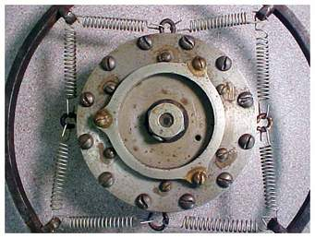 Figure 2.1: Carbon Microphone

When sound waves strike the carbon microphone diaphragm it vibrates, exerting a varying pressure onto the carbon. These varying pressure levels are translated into varying levels of resistance, which in turn vary the current passing through the microphone
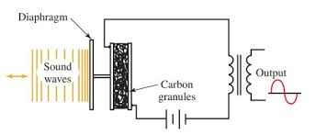Figure 2.2: Schematic Diagram
As radio started to be used, the carbon microphone was initially used there as well – for broadcasting as well as communications purposes. However their use in broadcast applications soon came to end because of the drawbacks of noise and poor frequency response. Other types of microphone started to become available and their use was preferred because of the better fidelity that was available. The use of the carbon microphone persisted for many years for communications purposes as they gave a high output and they were robust. The poor frequency response was not an issue.
The carbon microphone was used for telephones up until the 1970s and 1980s, but even there it became possible to use other types of microphone more conveniently. Also the crackle and noise of the carbon microphone had always been an issue and when other types of microphone became available at a low cost they started t be used, despite the requirement for additional electronics needed.
Carbon microphones are now only used in a very few applications – typically only specialist applications. They are able to withstand high voltage spikes and this property lends itself to use in a small number of applications

Advantages of Carbon Microphone
- High output
- Simple principle & construction
- Cheap and simple to manufacture

Disadvantages of Carbon microphone
- Very noisy - high background noise and on occasions it would crackle
- Poor frequency response
- Requires battery or other supply for operation
CRYSTAL MICROPHONE
A crystal microphone or piezo microphone uses the phenomenon of piezoelectricity—the ability of some materials to produce a voltage when subjected to pressure—to convert vibrations into an electrical signal. An example of this is potassium sodium tartrate, which is a piezoelectric crystal that works as a transducer, both as a microphone and as a slimline loudspeaker component. Crystal microphones were once commonly supplied with vacuum tube (valve) equipment, such as domestic tape recorders. Their high output impedance matched the high input impedance (typically about 10 megohms) of the vacuum tube input stage well. They were difficult to match to early transistor equipment and were quickly supplanted by dynamic microphones for a time, and later small electret condenser devices. The high impedance of the crystal microphone made it very susceptible to handling noise, both from the microphone itself and from the connecting cable.
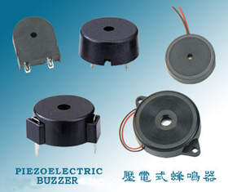Figure 2.3 : Piezoelectric Rubber
Piezoelectric transducers are often used as contact microphones to amplify sound from acoustic musical instruments, to sense drum hits, for triggering electronic samples, and to record sound in challenging environments, such as underwater under high pressure. Saddle-mounted pickups on acoustic guitars are generally piezoelectric devices that contact the strings passing over the saddle. This type of microphone is different from magnetic coil pickups commonly visible on typical electric guitars, which use magnetic induction, rather than mechanical coupling, to pick up vibration.

Advantages:
There are some advantages of piezoelectric transducer which are given below,
- The piezoelectric transducer is available in desired shape.
- It has rugged construction.
- It is small in size.
- It has good frequency response.
- It has negligible phase shift

Disadvantages:
There are some disadvantages of piezoelectric transducer which are given below,
- The piezoelectric transducer is used for dynamic measurement only.
- It has high temperature sensitivity.
- Some crystals are water soluble and get dissolve in high humid environment.

Applications:
There are some important applications of piezoelectric transducer which are given below,
- The piezoelectric transducer is used in spark ignition engines.
- It can be used in electronic watches.
- It is used in accelerometer.
- It is used in record player.
LOUDSPEAKERS
A loudspeaker is an electroacoustic transducer; a device which converts an electrical audio signal into a corresponding sound. The most widely used type of speaker in the 2010s is the dynamic speaker, invented in 1924 by Edward W. Kellogg and Chester W. Rice.

DYNAMIC SPEAKER
The dynamic speaker operates on the same basic principle as a dynamic microphone, but in the off reverse, to produce sound from an electrical signal. When an alternating current electrical audio signal is applied to its voice coil, a coil of wire suspended in a circular gap between the poles of a permanent magnet, the coil is forced to move rapidly back and forth due to Faraday's law of induction, which causes a diaphragm (usually conically shaped) attached to the coil to move back and forth, pushing on the air to create sound waves. Besides this most common method, there are several alternative technologies that can be used to convert an electrical signal into sound. The sound source (e.g., a sound recording or a microphone) must be amplified or strengthened with an audio power amplifier before the signal is sent to the speaker.

TWEETER
A tweeter is the smallest type of loudspeaker that is also known as the treble speaker. The speaker is designed to reproduce the upper limit of the audible frequency range. It varies between tweeters, but typically the sound frequency it delivers ranges from 2,000 Hz to 20,000 Hz.

MID-RANGE DRIVER
A mid-range speaker is a driver that is also known as a squawker. It is designed to deliver sound from 250 to 2000 Hz frequency range.

LOW RANGE OR BASS
The low range frequency gets reproduced by woofers and sub-woofers. The word gets derived from the dog’s barking or a ‘woof’, which uses lower frequency waves, compared to birds ‘tweeting’ that occupy the top of the audio spectrum.
The difference between woofers and sub-woofers is in the frequency range they are designed to reproduce with former typically working within the 40 Hz to 500 Hz range and latter occupying sub 100 Hz frequencies
Most consumer-grade loudspeakers combine woofers and sub-woofers into a single speaker, yet as you move up in the sound fidelity, those two get separated for purer, cleaner and more refined low-frequency sound.

WOOFER
A woofer, also called a bass speaker is a term for loudspeaker or a driver tasked with reproducing low frequency sounds.
Most of the time, it features a electrodynamic driver made of strong paper or various polymers.
With the lowest end of human hearing being around 20 Hz, woofers don’t typically exhaust human hearing capabilities working in 40 Hz and upwards range.

Figure 2.4: Piezoelectric speakers

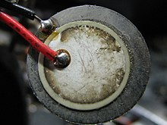
A piezoelectric buzzer. The white ceramic piezoelectric material can be seen fixed to a metal diaphragm.
Piezoelectric speakers are frequently used as beepers in watches and other electronic devices, and are sometimes used as tweeters in less-expensive speaker systems, such as computer speakers and portable radios. Piezoelectric speakers have several advantages over conventional loudspeakers: they are resistant to overloads that would normally destroy most high frequency drivers, and they can be used without a crossover due to their electrical properties. There are also disadvantages: some amplifiers can oscillate when driving capacitive loads like most piezoelectrics, which results in distortion or damage to the amplifier. Additionally, their frequency response, in most cases, is inferior to that of other technologies. This is why they are generally used in single frequency (beeper) or non-critical applications.
Piezoelectric speakers can have extended high frequency output, and this is useful in some specialized circumstances; for instance, sonar applications in which piezoelectric variants are used as both output devices (generating underwater sound) and as input devices (acting as the sensing components of underwater microphones). They have advantages in these applications, not the least of which is simple and solid state construction that resists seawater better than a ribbon or cone based device would.

Figure 2.5: Electrostatic loudspeaker
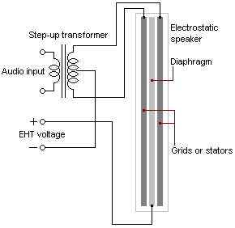
Schematic showing an electrostatic speaker's construction and its connections. The thickness of the diaphragm and grids has been exaggerated for the purpose of illustration.
Electrostatic loudspeakers use a high voltage electric field (rather than a magnetic field) to drive a thin statically charged membrane. Because they are driven over the entire membrane surface rather than from a small voice coil, they ordinarily provide a more linear and lower-distortion motion than dynamic drivers. They also have a relatively narrow dispersion pattern that can make for precise sound-field positioning. However, their optimum listening area is small and they are not very efficient speakers. They have the disadvantage that the diaphragm excursion is severely limited because of practical construction limitations—the further apart the stators are positioned, the higher the voltage must be to achieve acceptable efficiency. This increases the tendency for electrical arcs as well as increasing the speaker's attraction of dust particles. Arcing remains a potential problem with current technologies, especially when the panels are allowed to collect dust or dirt and are driven with high signal levels.

MOVING COIL LOUDSPEAKER
The moving coil loudspeaker is the most widely known and used form of loudspeaker. It can be found in many electronic items from radios to Bluetooth speakers and in public address systems - in fact anywhere that electrical waveforms need to be turned into audible sound.
The moving coil loudspeaker performs well and is able to be manufactured relatively easily. However, like all transducers converting electrical waveforms into sound, its operation can be complex as the moving coil loudspeaker links electrical and mechanical domains.
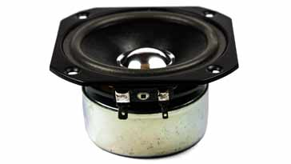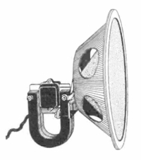
Figure 2.6: Moving Coil Speakers
The moving coil loudspeaker uses the magnetic effect generated by a flowing current as the basis of its operation.
When a current flows in a wire, a magnetic field appears around it. When the wire is wound into a coil, the effect is increased.
Wireless speakers are very similar to traditional (wired) loudspeakers, but they receive audio signals using radio frequency (RF) waves rather than over audio cables. There is normally an amplifier integrated in the speaker's cabinet because the RF waves alone are not enough to drive the speaker. This integration of amplifier and loudspeaker is known as an active loudspeaker. Manufacturers of these loudspeakers design them to be as lightweight as possible while producing the maximum amount of audio output efficiency.
Wireless speakers still need power, so require a nearby AC power outlet, or possibly batteries. Only the wire to the amplifier is eliminated.
ASSIGNMENT 2
- What are the factors that determine the qualities of a microphone and loudspeakers
- State five applications of transducers
- Discus on wireless microphone and wireless speakers
QUIZ 2
- Sketch the schematic diagram of one type of microphone and one type of speaker
- Differentiate between active and passive transducers

CHAPTER 3.0
BASIC PRINCIPLES OF MODULATION & DEMODULATION
Introduction

For successful transmission and reception of intelligence (code, voice, music etc.) by the use
of radio waves, two processes are essential : (i ) modulation and (ii ) demodulation.

Speech and music etc. are sent thousands of kilometres away by a radio transmitter. The scene in front of a television camera is also sent many kilometres away to viewers. Similarly, a Moon probe or Venus probe checking its environments, sends the information it gathers millions of kilometres through space to receivers on earth. In all these cases, the carrier is the high-frequency radio wave. The intelligence i.e. sight, sound or other data collected by the probe is impressed on the radio wave and is carried along with it to the destination.

Modulation is the process of combining the low-frequency signal with a very high-frequency
radio wave called carrier wave (CW). The resultant wave is called modulated carrier wave. This job is done at the transmitting station.
Demodulation is the process of separating or recovering the signal from the modulated carrier wave. It is just the opposite of modulation and is performed at the receiving end.

It is the process of combining an audio frequency (AF) signal with a radio frequency(RF) carrier wave. The AF signal is also called a modulating wave and the resultant wave produced is called modulated wave.
Modulation is the superimposing of a low frequency (audio signal) on a high frequency (carrier wave). It is the process through which audio, video, image, or text information is added to an electrical or optical carrier signal to be transmitted over a telecommunication or electronic medium
What is a Carrier Wave?

It is a high-frequency undamped radio wave produced by radio-frequency oscillators , the output of these oscillators is first amplified and then passed on to an antenna. This antenna radiates out these high-frequency (electromagnetic) waves into space. These waves have constant amplitude and travel with the velocity of light. They are inaudible i.e. by themselves they cannot produce
any sound in the loudspeaker of a receiver. As their name shows, their job is to carry the signal
(audio or video) from transmitting station to the receiving station. The resultant wave is called
modulated carrier wave as shown in figure 3.1

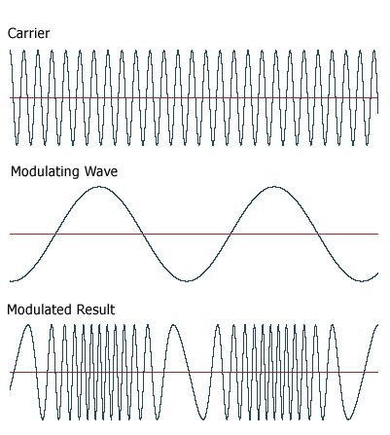
Figure 3.1 Carrier and modulating waves combined to form a modulated wave

Table 3.1: Differences between Modulation and Demodulation
Modulation | Demodulation
Encoding of information | Decoding of information
Superimposing | Retrieving
Varying some parameters like amplitude, frequency and phase | Extraction of the audio signal from the transmitted modulated wave
Takes place at the source/transmitting end | Takes place at the destination/receiving end
Frequency transformation from low to high | Frequency transformation from high to low
Circuit modulator needed | Circuit demodulator needed
Operation is simple | Operation is complex

Need for Modulation

Sometimes, beginners question the necessity of modulation i.e. using a carrier wave to carry the low-frequency signal from one place to another. Why not transmit the signals directly and save lot of botheration? Unfortunately, there are three main hurdles in the process of such direct transmission of audio-frequency signals:

1. They have relatively short range,
2. If everybody started transmitting these low-frequency signals directly, mutual interference will render all of them ineffective
3. Size of antennas required for their efficient radiation would be large i.e. about 75 km
For efficient radiation of a signal, the minimum length of an antenna is one quarter wavelength
(λ/4). The antenna length L is connected with the frequency of the signal wave by the relation
L = 75 × 106/f metres. For transmitting an audio signal of f = 1000 Hz, L = 75 × 106/103 = 75,000 m = 75 km ! In view of this immense size of antenna length, it is impractical to radiate audio-frequency signals directly into space.

Hence, the solution lies in modulation which enables a low-frequency signal to travel very large
distances through space with the help of a high-frequency carrier wave. These carrier waves need
reasonably-sized antennas and produce no interference with other transmitters operating in the same area.

Modulation is needed:
- For ease of radiation
- To reduce noise and interference
- To overcome equipment limitations

BENEFITS OF MODULATION

- It helps to send a signal over a bandpass frequency range
- It allows use of smaller antenna
- It increases the range of communication
- It improves quality of reception
- It avoids mixing of signals
- Multiplexing is possible

APPLICATIONS OF MODULATION

- For broadcasting (radio and television), AM, FM, PM etc
- GSM (global system for mobile communication)
- Radar ( Radio Detection and Ranging)
- WiFi
- Conversion of analog signal to digital signal

Methods of Modulation
The mathematical expression for a sinusoidal carrier wave is

e = EC sin (ωc t + φ) = EC sin (2 πfc t + φ)

Obviously, the waveform can be varied by any of its following three factors or parameters :
1. EC — the amplitude, 2. fc — the frequency, 3. φ — the phase.

Accordingly, there are three types of sine-wave modulations known as :

1. Amplitude Modulation (AM)
Here, the information or AF signal changes the amplitude of the carrier wave without changing
its frequency or phase.

2. Frequency Modulation (FM)
In this case, the information signal changes the frequency of the carrier wave without changing
its amplitude or phase.

3. Phase Modulation (PM)
Here, the information signal changes the phase of the carrier wave without changing its other
two parameters.

Amplitude Modulation

In this case, the amplitude of the carrier wave is varied in proportion to the instantaneous amplitude of the information signal or AF signal. Obviously, the amplitude (and hence the intensity) of the carrier wave is changed but not its frequency. Greater the amplitude of the AF signal, greater the fluctuations in the amplitude of the carrier wave.
The process of amplitude modulation is shown graphically in Figure. For the sake of simplicity, the AF signal has been assumed sinusoidal. The carrier wave by which it is desired to transmit the AF signal is shown. The resultant wave called modulated wave is also shown in the Figure.
The function of the modulator is to mix these two waves. All stations broadcasting on the standard broadcast band (550-1550 kHz) use AM modulation. If you observe the envelope of the
modulated carrier wave, you will realize that it is an exact replica of the AF signal wave.
In summary
(i ) fluctuations in the amplitude of the carrier wave depend on the signal amplitude,
(ii ) rate at which these fluctuations take place depends on the frequency of the audio signal

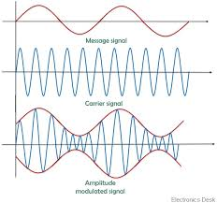
Figure 3.3 Message signal, carrier wave and their mixing

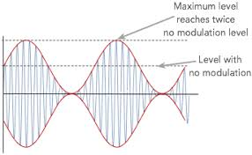
Figure 3.4 Modulated wave

Percent Modulation

It indicates the degree to which the AF signal modulates the carrier wave

m = maximum value of signal wave X 100 = Signal amplitude X 100

maximum value of carrier wave Carrier amplitude

This is referred to as modulation index (MI)

i.e m = (modulation factor) = M.I X 100

In the image below for amplitude modulated sine wave:
- 0% unmodulated, the sine envelope is not visible at all;
- < 100% modulation depth is normal AM use;
- 100% modulation depth, the sine envelope touch at y=0. Maximum modulation that can be retrieved with an envelope detector without distortion;
- > 100% modulation depth, "overmodulation", the original sine wave can no longer be detected with an envelope detector.
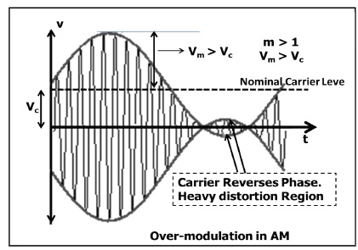 Figure 3.5
Over modulation isn't really of any significance to FM systems (unlike AM). If the modulation signal amplitude is too great, any decent frequency modulator will limit the signal so that it can't push the bandwidth of the modulated signal too wide in the frequency spectrum. In effect, the modulating signal becomes clipped.

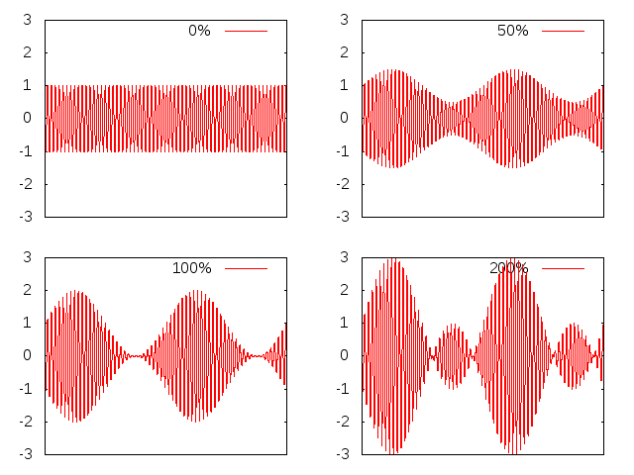

Figure 3.6: Various levels of modulation

The following points are the
- A carrier is used to make the wavelength smaller for practical transmission and to permit multiplexing.
- The spectrum is used to measure bandwidth (the range of frequencies) and the efficiency (the power in the side-bands compared to the total power)
- Bandwidth can be predicted using BW = 2 f_{m} where f_{m} = the maximum modulating frequency
- Efficiency depends only on the modulating index, m (the fraction of the carrier you modulate by)
- AM is limited to 33% efficiency because the modulation index cannot be increased to > 1.0 without introducing distortion in the receiver.
Upper and Lower Side Frequencies

An unmodulated carrier wave consists of only one single-frequency component of frequency
fc. When it is combined with a modulating signal of frequency fm, heterodyning action takes place.
As a result, two additional frequencies called side frequencies are produced. The AM wave is found to consist of three frequency components :
1. The original carrier frequency component, fc .
2. A higher frequency component (fc+ fm). It is called the sum component.
3. A lower frequency component (fc – fm). It is called the difference component.

The two new frequencies are called the upper-side frequency (USF) and lower-side frequency LSF) respectively and are symmetrically located around the carrier frequency.
The modulating frequency remains unchanged but does not appear in the amplifier output because the amplifier's load presents practically zero impedance to this low frequency.
These are shown in time domain in Figure below
The amplitude of the side frequencies depends on the value of m. The amplitude of each side frequency = mA/2 where A is the amplitude of unmodulated carrier wave

Example 3.1 A 10-MHz sinusoidal carrier wave of amplitude 10 mV is modulated by a
5 kHz sinusoidal audio signal wave of amplitude 6 mV. Find the frequency components of the resultant modulated wave and their amplitudes.

Solution. Here, fc = 10 MHz and fm = 5 kHz = 0.005 MHz. The modulated carrier contains the
following frequencies :
1. original carrier wave of frequency fc = 10 MHz
2. USF of frequency = 10 + 0.005 = 10.005 MHz
3. LSF of frequency = 10 – 0.005 = 9.995 MHz

Here,

m = maximum value of signal wave X 100 = Signal amplitude X 100

maximum value of carrier wave Carrier amplitude

= 6/10 = 0.6

Amplitude of LSF = USF = mA/2 = 0.6 × 10/2 = 3 mV

It was assumed that the modulating signal was composed of one frequency component only. However, in a broadcasting station, the modulating signal is the human voice (or music) which contains waves with a frequency range of 20-4000 Hz. Each of these waves has its own LSF and USF. When combined together, they give rise to an upper-side band (USB) and a lower-side band (LSB). The USB, in fact, contains all sum components of the signal and carrier frequency whereas LSB contains their difference components.
The channel width (or bandwidth) is given by the difference between extreme frequencies i.e. between maximum frequency of USB and minimum frequency of LSB.
As seen, Channel width = 2 × maximum frequency of modulating signal = 2 × fm (max)

Example 3.2. An audio signal given by 15 sin 2π (2000 t) amplitude-modulates a sinusoidal carrier wave 60 sin 2π (100,000) t.
Determine :
(a) modulation index, (b) percent modulation, (c) frequencies of signal and carrier,
(d) frequency spectrum of the modulated wave.

Solution. Here, B = 15 and A = 60
    - M.I. = B/A = 15/60 = 0.25
    - m = M.I. × 100 = 0.25 × 100= 25%
(c) fm = 2000 Hz — by inspection of the given equation
fc = 100,000 Hz — by inspection of the given equation
(d) The three frequencies present in the modulated CW are
(i ) 100,000 Hz = 100 kHz
(ii ) 100,000 + 2000 = 102,000 Hz =102 kHz
(iii ) 100,000 – 2000 = 98,000 Hz = 98 kHz

Example 3.3. A bandwidth of 15 MHz is available for AM transmission. If the maximum audio
signal frequency used for modulating the carrier is not to exceed 15 kHz, how many stations can
broadcast within this band simultaneously without interfering with each other?

Solution. BW required by each station =2 fm(max) = 2 × 15 = 30 kHz
Hence, the number of station which can broadcast within this frequency band without interfering
with one another is
= 15 MHz/30kHz = 500

Example 3.4. In a broadcasting studio, a 1000 kHz carrier is modulated by an audio signal of
frequency range, 100-5000 Hz. Find (i) width or frequency range of sidebands (ii) maximum and
minimum frequencies of USB (iii) maximum and minimum frequencies of LSB and (iv) width of the channel.

Solution: (i) Width of sideband = 5000 – 100 = 4900 Hz
(ii) Max. frequency of USB = 1000 + 5 = 1005 kHz
Min. frequency of USB = 1000 + 0.1 = 1000.1 kHz
(iii )Max. frequency of LSB = 1000 – 0.1 = 999.9 kHz
Min. frequency of LSB = 1000 – 5 = 995 kHz
(iv) Width of channel = 1005 – 995 = 10 kHz

Example 3.5
A transmitter radiates 9kw without modulation and 10.125kw after modulation. Determine the depth of modulation.

Solution:
Pc = 9kw , Pmod = 10.125kw

Now Pmod = Pc (1 + ma² /2)

(1 + ma² / 2) = 10.125 / 9 = 1.125

ma = 0.5

Advantages of AM over FM
- Circuits for AM transmitter and receiver are simple and less expensive
- AM signal can go so far in propagation
- AM never suffers multi-path filtering
- AM is easier to listen to with portable radios, not needing external wire antenna with local contents

Limitations of AM

- It’s power is not efficient
- The bandwidth is equal to double of the highest audio frequency (the bandwidth required by AM is less (2 fm)
- AM are sensitive to high level of noise
- AM has poorer sound quality

APPLICATIONS OF AM
In amplitude modulation (AM), amplitude of carrier signal is varied in accordance with message signal. Amplitude modulation has many real world applications. Those are:
- AM is used for broadcasting in long wave or medium wave or short wave bands.
- The Very High Frequency (VHF) transmission is processed by AM. Radio communication uses VHF.
- A special type of AM is Quadrature Amplitude Modulation (QAM). It is used for data transmission from short range transmission to cellular communications.

Forms of Amplitude Modulation
As shown, one carrier and two sidebands are produced in AM generation. It is found that it is not necessary to transmit all these signals to enable the receiver to reconstruct the original signal. Accordingly, we may attenuate or altogether remove the carrier or any one of the sidebands without affecting the communication process. The advantages would be

1. less transmitted power and 2. less bandwidth required

The different suppressed component systems are :
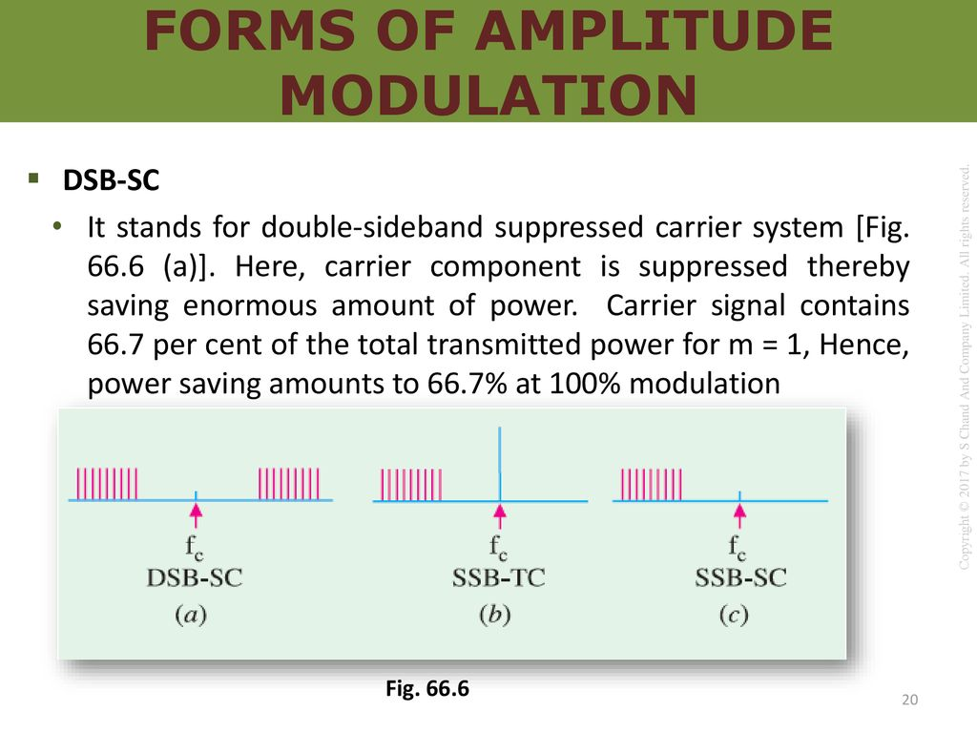
(a)

Figure 3.7
below
(b) SSB-TC
In this case, one sideband is suppressed but the other sideband and carrier are transmitted. It is called single sideband transmitted carrier system. For m = 1, power saved is 1/6 of the total transmitted power

(c) SSB-SC
This is the most dramatic suppression of all because it suppresses one sideband and the carrier and transmits only the remaining sideband. In the standard or double-sideband full-carrier (DSB.FC) AM, carrier conveys no information but contains maximum power. Since the two sidebands are exact images of each other, they carry the same audio information. Hence, all information is available in one sideband only.

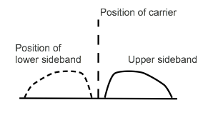Figure 3.8

Obviously carrier is superfluous and one side band is redundant. Hence, one sideband and the carrier can be discarded with no loss of information. The result is SSB signal. The advantage of SSB-SC system are as follows :
1. Total saving of 83.3% in transmitted power (66.7% due to suppression of carrier wave and 16.6% due to suppression of one sideband). Hence, power is conserved in an SSB transmitter.
2. Bandwidth required is reduced by half i.e. 50%. Hence, twice as many channels can be multiplexed in a given frequency range.
3. The size of power supply required is very small. This fact assumes vital importance particularly in a spacecraft.
4. Since the SSB signal has narrower bandwidth, a narrower passband is permissible within the receiver, thereby limiting the noise pick up.
However, the main reason for wide spread use of DSB-FC (rather than SSB-SC) transmission in broadcasting is the relative simplicity of its modulating equipment

Methods of Amplitude Modulation
There are two methods of achieving amplitude modulation :
(i ) Amplifier modulation,
(ii ) Oscillator modulation.
.
Here, carrier and AF signal are fed to an amplifier and the result is an AM output
The modulation process takes place in the active device used in the amplifier.

Block Diagram of an AM Transmitter
Figure 3.9 shows the block diagram of a typical transmitter. The carrier wave is supplied by a crystal-controlled oscillator at the carrier frequency. It is followed by a tuned buffer amplifier and an RF output amplifier. The source of AF signal is a microphone. The audio signal is amplified by a low level audio amplifier and, finally, by a power amplifier. It is then combined with the carrier to produce a modulated carrier wave which is ultimately radiated out in the free space by the transmitter antenna as shown.

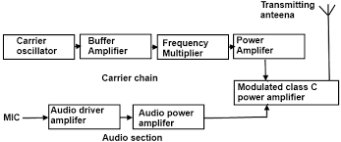
Figure 3.9 : Block Diagram of AM

FREQUENCY MODULATION

Frequency modulation (FM) is the encoding of information in a carrier wave by varying the instantaneous frequency of the wave. The term and technology is used in both telecommunications and signal processing.
In analog frequency modulation, such as FM radio broadcasting of an audio signal representing voice or music, the instantaneous frequency deviation, the difference between the frequency of the carrier and its center frequency, is proportional to the modulating signal.
In frequency modulation, the frequency of the carrier signal is varied in proportional to (in accordance with) the Amplitude of the input modulating signal. The input is a single tone sine wave. The carrier and the FM waveforms also are shown in the following figure.

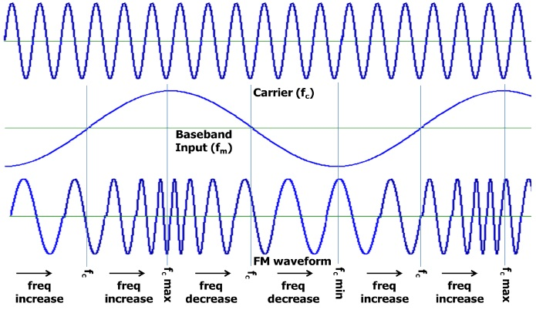
Figure 3.10: Frequency Modulation waveform

As the name shows, in this modulation, it is only the frequency of the carrier which is changed and not its amplitude. The amount of change in frequency is determined by the amplitude of the modulating signal whereas rate of change is determined by the frequency of the modulating signal. As shown in the figure above, in an FM carrier, information (or intelligence) is carried as variations in its frequency. As seen, frequency of the modulated carrier increases as the signal amplitude increases but decreases as the signal amplitude decreases. It is at its highest frequency (point H) when the signal amplitude is at its maximum positive value and is at its lowest frequency (point L) when signal amplitude has maximum negative value. When signal amplitude is zero, the carrier frequency is at its normal frequency f0 (also called resting or centre frequency.). This louder signal causes greater frequency change in modulated carrier as indicated by increased bunching and spreading of the waves as compared with relatively weaker signal. The rate at which frequency shift takes place depends on the signal frequency if the modulating signal is 1 kHz, then the modulated carrier will swing between its maximum frequency and lowest frequency 1000 times per second. If fm = 2 kHz, the rate of frequency swing would be twice as fast :
In short, we have established two important points about the nature of frequency modulation:

- The amount of frequency deviation (or shift or variation) depends on the amplitude (loudness) of the audio signal. Louder the sound, greater the frequency deviation and vice-versa. However, for the purposes of FM broadcasts, it has been internationally agreed to restrict maximum deviation to 75 kHz on each side of the centre frequency for sounds of maximum loudness. Sounds of lesser loudness are permitted proportionately less frequency deviation.

(ii) The rate of frequency deviation depends on the signal frequency.

Frequency Deviation and Carrier Swing
The frequency of an FM transmitterwithout signal input is called the resting frequency or centre frequency (f0) and is the allotted frequency of the transmitter. In simple words, it is the carrier frequency on which a station is allowed to broadcast.When the signal is applied, the carrier frequency deviates up and down from its resting value f0. This change or shift either above or below the resting frequency is called frequency deviation (Δf) The total variation in frequency from the lowest to the highest is called carrier swing (CS).

Obviously, carrier swing = 2 × frequency deviation of CS = 2 × Δf

A maximum frequency deviation of 75 kHz is allowed for commercial FM broadcast stations inthe 88 to 168 MHz VHF band. Hence, FM channel width is 275 = 150 kHz. Allowing a 25 kHz guard band on either side, the channel width becomes = 2(75 + 25) = 200 kHz This guard band is meant to prevent interference between adjacent channels. However, a maximum frequency deviation of 25 kHz is allowed in the sound portion of the TV broadcast.

In FM, the highest audio frequency transmitted is 15 kHz. Consider an FM carrier of resting frequency 100 MHz. Since (Δf)max = 75 kHz, the carrier frequency can swing from the lowest value of 99.925 MHz to the highest value of 100.075 MHz. Of course, deviations lesser than 75 kHz corresponding to relatively softer sounds are always permissible.
Modulation Index
It is given by the ratio $mf=\frac{frequencydeviation}{modulation frequency}$ $=\frac{∆f}{fm}$

Unlike amplitude modulation, this modulation index can be greater than unity. By knowing the value of mf, we can calculate the number of significant sidebands and the bandwidth of the FM signal.

Deviation Ratio
It is the worst-case modulation index in which maximum permitted frequency deviation and
maximum permitted audio frequency are used

$∴deviation ratio=\frac{( ∆f )}{fm(max){}}$

Now, for FM broadcast stations, ($∆$f)max = 75 kHz and maximum permitted frequency of modulating audio signal is 15 kHz

$∴deviation ratio=\frac{75KHZ}{15KHZ}$ = 5

For sound portion of commercial TV deviation ratio = $\frac{25KHZ}{15KHZ}$ = 1.67

Percent Modulation

When applied to FM, this term has slightly different meaning than when applied to AM. In FM, it is given by the ratio of actual frequency deviation to the maximum allowed frequency deviation

$m$ $=\frac{\left(∆f\right)actual}{\left(∆f\right)max}$
Obviously, 100% modulation corresponds to the case when actual deviation equals the maximum allowable frequency deviation. If, in some case, actual deviation is 50 kHz, then

$m$ $=\frac{50}{75}$ = 0.667 =66.7%

Value of m = 0 corresponds to zero deviation i.e. unmodulated carrier wave. It is seen from the above equation that m ∝ (Δf)actual. It means that when frequency deviation (i.e. signal loudness) is doubled, modulation is doubled.

Example 3.6. What is the modulation index of an FM carrier having a carrier swing of 100
kHz and a modulating signal of 5 kHz ?

Solution. CS = 2 ×$∆$ f

$∴∆ f=\frac{CS}{2}$ = $\frac{100}{2}$ = 50Khz, $∴$ $mf$ $=\frac{\left(∆f\right)}{fm}$ = $\frac{50}{5}$ = 10

Example. 3.7. An FM transmission has a frequency deviation of 18.75 kHz. Calculate percent
modulation if it is broadcast
- in the 88-108 MHz band (ii) as a portion of a TV broadcast

Solution. (i) For this transmission band,
(Δf)max = 75 kHz $∴$ $m$ $=\frac{18.75}{75}$ X 100 = 25%
(ii ) In this case, (Δ f)max = 25 kHz $∴$ $m$ $=\frac{18.75}{25}$ X 100 = 75%

Example 3.8. An FM signal has a resting frequency of 105 MHz and highest frequency of 105.03 MHz when modulated by a signal of frequency 5 kHz. Determine

(i) frequency deviation, (ii) carrier swing, (iii) modulation index,
(iv) percent modulation, (v) lowest frequency reached by the FM wave.

Solution. (i) Δ f = 105.03 – 105= 0.03 MHz = 30 kHz
- CS = 2 × Δf = 2 × 30 = 60 kHz
- $mf$ $=\frac{30}{5}$ = 6
- $mf$ $=\frac{30}{5}$ X 100 = 60%
- lowest frequency = 105 – 0.03 = 104.97 kHz

FM Sidebands

In FM, when a carrier is modulated, a number of sidebands are formed.* Though theoretically their number is infinite, their strength becomes negligible after a few sidebands. They lie on both sides of the centre frequency spaced fm apart. Sidebands at equal distances from f0 have equal amplitudes. If f0 is the centre frequency and fm the frequency of the modulating signal, then FM carrier contains the following frequencies :

(i) f0 (ii) f0 ± fm (iii ) f0 ± 2 fm (iv) f0 ± 3 fm and so on

The bandwidth occupied by the spectrum is BW = 2nfm where n is the highest order of the significant sideband.
Another approximate expression for spectrum bandwidth is BW = 2 (1 + mf)fm
$Now,$ $mf$ $=\frac{\left(∆f\right)}{fm}$, hence BW = 2 (Δf + fm)
This expression is based on the assumption that sidebands having amplitudes less than 5% of the
unmodulated carrier wave are negligble or when mf is at least 6.

Modulation Index and Number of Sidebands

It is found that the number of sidebands
1. depends directly on the amplitude of the modulating signal,
2. depends inversely on the frequency of the modulating signal.
Since frequency deviation is directly related to the amplitude of the modulating signal, the above
two factors can be combined in one factor called modulation index.

Hence, number of sidebands depends on mf = Δf / fm

Obviously, the number of pairs of sidebands

(i) increases as frequency deviation (or amplitude of modulating signal) increases.
(ii) increases as the modulating signal frequency decreases.

Example 3.9. A 5 kHz audio signal is used to frequency-modulate a 100 MHz carrier causing
a frequency deviation of 20 kHz. Determine
- modulation index (ii) bandwidth of the FM signal.
Solution. (i) $mf$ $=\frac{\left(∆f\right)}{fm}$ $=\frac{20}{5}$ - 4

When mf = 4, and n= 7,
BW =14fm = 14 × 5 = 70 kHz

Example 3.10. In an FM circuit, the modulation index is 10 and the higest modulation frequency
is 20 kHz. What is the approximate bandwidth of the resultant FM signal ?
Solution. Since the value of mf is more than 6, we will use the expression
BW = 2 (Δf + fm)

$Now mf$ $=\frac{\left(∆f\right)}{fm}$ $or 10 =\frac{\left(∆f\right)}{20}$ , $∴$ Δf = 200 kHz

$∴$ BW = 2 (200 + 20) = 440 kHz

Comparison Between AM and FM

Frequency modulation (FM) has the following advantages as compared to amplitude modulation (AM) :

1. All transmitted power in FM is useful whereas in AM most of it is in carrier which serves
no useful purpose.
2. It has high signal-to-noise (S/N) ratio. It is due to two reasons : firstly, there happens to be
less noise at VHF band and secondly, FM receivers are fitted with amplitude limiters
which remove amplitude variations caused by noise.
3. Due to ‘guard-band’ there is hardly any adjacent-channel interference.
4. Since only transmitter frequency is modulated in FM, only fraction of a watt of audio
power is required to produce 100% modulation as compared to high power required in AM.

However, FM has the following disadvantages :

1. It requires much wider channel —almost 7 to 15 times as large as needed by AM.
2. It requires complex and expensive transmitting and receiving equipment.
3. Since FM reception is limited to only line of sight, area of reception for FM is much smaller
than for AM.

APPLICATIONS OF FM

There are four major areas of application for FM transmission:
1. First use is in FM broadcast band 88-108 MHz with 200 kHz channels in which commercial
FM stations broadcast programmes to their listeners.
2. Second use is in TV. Though video signal is amplitude-modulated, sound is transmitted by
a separate transmitter which is frequency-modulated.
3. Third use is in the mobile or emergency services which transmit voice frequencies (20-
4000 Hz) only.
4. Fourth use is in the amateur bands where again only voice frequencies are transmitted
ASSIGNMENT 3

- The antenna current of an AM transmitter is 8A when only carrier is sent out. It increases to 8.93A when the carrier is sinusoidally modulated. Find the percentage modulation?
- A carrier wave of 600watts is subjected to 100% amplitude modulation. Determine
  - Power in sideband (ii) power of modulated wave
- A 5 kHz audio signal is used to frequency-modulate a 100 MHz carrier causing a frequency deviation of 20 kHz. Determine
  - modulation index (ii) bandwidth of the FM signal.

QUIZ 3

- What are the consequences of overmodulation?
- A 40kw carrier is to be modulated to a level of 100%.
  - What is the carrier power after modulation
  - How much audio power is required if the efficiency of the modulated RF amplifier is 72%
- An FM signal has a resting frequency of 95 MHz and highest frequency of 95.03 MHz when modulated by a signal of frequency 5 kHz. Determine
(i) frequency deviation, (ii) carrier swing, (iii) modulation index,
(iv) percent modulation, (v) lowest frequency reached by the FM wave.

PRACTICAL SESSION

- Students are to experiment how AM is generated using the necessary laboratory equipment
- A report is to be submitted after

CHAPTER 4.0
RADIO & TELEVISION TRANSMISSION
Radio Broadcasting

Let us see how radio broadcasting stations broadcast speech or music etc. from their broadcasting studios. First, the speech or music which consists of a series of compressions and rarefactions is translated into a tiny varying electric current with the help of a crystal microphone. The frequency of variations of this current lies in the audio-range, hence it is known as audio frequency signal. The audio-frequency signal cannot be radiated out from the antenna directly because transmission at audio-frequencies is not practical. For this purpose, oscillations of very high frequency or radio-frequency are produced with the help of any one of the oscillators
The electromagnetic waves so produced are of constant amplitude but of extremely high frequency. These waves, which are neither seen nor heard, travel through space with the velocity of light i.e. 3 × 108 m/s (approx). The audio frequency signal which is to be broadcast, is then superimposed on the RF waves, which are known as carrier waves (because they carry A.F. signal through space to distant places). In a way, the carrier waves can be likened to a horse and the audio-frequency signal to a rider. The process by which AF signal or information is impressed on the carrier wave is known as modulation. The horse and rider travel through space. At the receiving end, they strike the receiving aerial and enter the receiver which separates the horse from the rider. The horse i.e. carrier wave is returned and the rider i.e. audio-frequency signal is converted back into sound. This process by which the R.F. waves and A.F. waves are separated is known as detection or demodulation (because it is the reverse of modulation).

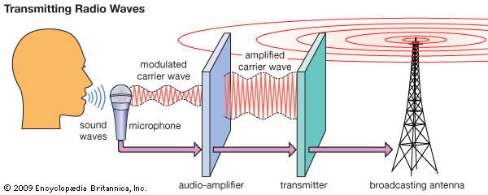

Figure 4.1: Transmission of radio waves

In sound transmission, the initial sound is first picked up by a microphone. The microphone generates a pulsating direct current called a black wave. Meanwhile an oscillator supplies a carrier wave. Electrical circuits combine the black wave and carrier wave into a modulated carrier pulse of alternating current. This pulse is amplified and used to radiate a carrier wave.
In radio transmission, a radiating antenna is used to convert a time-varying electric current into an electromagnetic wave or field, which freely propagates through a nonconducting medium such as air or space. In a broadcast radio channel, an omnidirectional antenna radiates a transmitted signal over a wide service area. In a point-to-point radio channel, a directional transmitting antenna is used to focus the wave into a narrow beam, which is directed toward a single receiver site. In either case the transmitted electromagnetic wave is picked up by a remote receiving antenna and reconverted to an electric current.

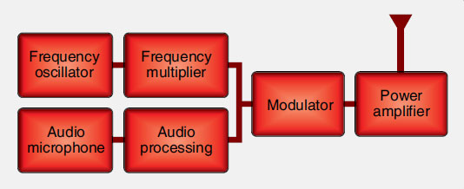

Figure 4.2 Block diagram of A Basic Radio Transmitter

A transmitter consists of a precise oscillating circuit or oscillator that creates an AC carrier wave frequency. This is combined with amplification circuits or amplifiers. The distance a carrier wave travels is directly related to the amplification of the signal sent to the antenna.

Modern transmitters are highly refined devices with extremely precise frequency oscillation and modulation. The circuitry for controlling, filtering, amplifying, modulating, and oscillating electronic signals can be complex.
Transceivers
A transceiver is a communication radio that transmits and receives. The same frequency is used for both. When transmitting, the receiver does not function. The push to talk (PTT) switch blocks the receiving circuitry and allows the transmitter circuitry to be active. In a transceiver, some of the circuitry is shared by the transmitting and receiving functions of the device. So is the antenna. This saves space and the number of components used. Transceivers are half duplex systems where communication can occur in both directions but only one party can speak while the other must listen. VHF aircraft communication radios are usually transceivers.

BLACK & WHITE (MONOCHROME) TRANSMITTER
An over simplified block diagram of a monochrome TV transmitter is shown in Fig . The functional block diagram can be broadly divided into two sections, viz. an amplitude modulated transmitter and a frequency modulated transmitter. Former is used for video modulation, whereas latter is used for audio modulation.

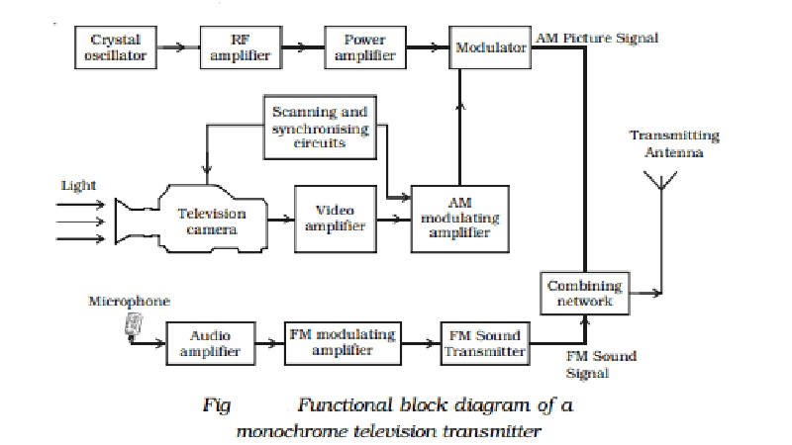
Figure 4.3

The block diagram can be broadly divided into two -sections, viz., an amplitude modulated transmitter and a frequency modulated transmitter. Former is used for video modulation whereas latter is used for audio modulation.
However only one antenna is used for transmission of the video as well as audio signals. Thus these modulated signals have to be combined together in some appropriate network. In addition there are other accessories also. For instance, video as well as audio signals have to be amplified to the desired degree before they modulate their respective RF carriers.
This function is performed by video and audio amplifiers
The synchronising and scanning circuits produce sets of pulses for providing synchronising pulses for proper functioning of the TV system. This timing unit contains number of wave generating and wave shaping circuits. The repetition rate of its various output pulse trains is controlled by a frequency stabilised master oscillator.
The output signal of a camera tube corresponding to the image to be televised is amplified through a number of video amplifier stages.
The image signals together with the synchronising and blanking pulses are raised to a level suitable for modulating the RF carrier wave generated in the RF channel. The allotted picture carrier frequency is generated by the crystal controlled oscillator. The continuous wave output is given large amplification before feeding to the power amplifier. In the modulator, its amplitude is made to vary in accordance with the modulating signal received from the modulating amplifier.
The microphone converts the sound associated with the picture being televised into proportionate electrical signal. The audio signal from the microphone after amplification is frequency modulated, employing the assigned carrier frequency. The output of the sound FM transmitter is finally combined with the AM picture transmitter output, through a combining network and fed to a common antenna for radiation of energy in the form of electromagnetic waves.

Compatible colour television
Compatible colour television represents electronic technology at its pinnacle of achievement, carefully balancing the needs of human perception with the need for technological efficiency. The transmission of colour images requires that extra information be added to the basic monochrome television signal, described above. At the same time, this more complex colour signal must be “compatible” with black-and-white television, so that all sets can pick up and display the same transmission. The design of compatible colour systems, accomplished in the 1950s, was truly a marvel of electrical engineering. The fact that the standards chosen at that time are still in use attests to how well they were designed

Generating the colour picture signal
The colour television signal actually consists of two components, luminance (or brilliance) and chrominance; and chrominance itself has two aspects, hue (colour) and saturation (intensity of colour). The television camera does not produce these values directly; rather, it produces three picture signals that represent the amounts of the three primary colours (blue, green, and red) present at each point in the image pattern. From these three primary-colour signals the luminance and chrominance components are derived by manipulation in electronic circuits.
Immediately following the colour camera is the colour coder, which converts the primary-colour signals into the luminance and chrominance signals. The luminance signal is formed simply by applying the primary-colour signals to an electronic addition circuit, or adder, that adds the values of all three signals at each point along their respective picture signal wave forms. Since white light results from the addition (in appropriate proportions) of the primary colours, the resulting sum signal represents the black-and-white (luminance) version of the colour image. The luminance signal thus formed is subtracted individually, in three electronic subtraction circuits, from the original primary-colour signals, and the colour-difference signals are then further combined in a matrix unit to produce the I (orange-cyan) and Q (magenta-yellow) signals. These are applied simultaneously to a modulator, where they are mixed with the chrominance subcarrier signal. The chrominance subcarrier is thereby amplitude modulated in accordance with the saturation values and phase modulated in accordance with the hues. The luminance and chrominance components are then combined in another addition circuit to form the overall colour picture signal.
Horizontal and vertical deflection currents, which produce the scanning in the three camera sensors, are formed in a scanning generator, the timing of which is controlled by the chrominance subcarrier. This common timing of deflection and chrominance transmission produces the dot-interference cancellation in monochrome reception and the frequency interlacing in colour transmission

The carrier signal
The picture signal generated as described above can be conveyed over short distances by wire or cable in unaltered form, but for broadcast over the air or transmission over cable networks it must be shifted to appropriately higher frequency channels. Such frequency shifting is accomplished in the transmitter, which essentially performs two functions: (1) generation of very high frequency (VHF) or ultrahigh frequency (UHF) carrier currents for picture and sound, and (2) modulation of those carrier currents by imposing the television signal onto the high-frequency wave. In the former function (generation of the carrier currents), precautions are taken to ensure that the frequencies of the UHF or VHF waves have precisely the values assigned to the channel in use. In the latter function (modulation of the carrier wave), the picture signal wave form changes the strength, or amplitude, of the high-frequency carrier in such a manner that the alternations of the carrier current take on a succession of amplitudes that match the shape of the signal wave form. This process is known as amplitude modulation (AM).

The sound signal
The sound program accompanying a television picture signal is transmitted by equipment similar to that used for frequency-modulated (FM) radio broadcasting. In the NTSC system, the carrier frequency for this sound channel is spaced 4.5 megahertz above the picture carrier and is separated from the picture carrier in the television receiver by appropriate circuitry. The sound has a maximum frequency of 15 kilohertz (15,000 cycles per second), thereby assuring high fidelity. Stereophonic sound is transmitted through the use of a subcarrier located at twice the horizontal sweep frequency of 15,734 hertz. The stereo information, encoded as the difference between the left and right audio channel, amplitude modulates the stereo subcarrier, which is suppressed if there is no stereo difference information. The base sound signal is transmitted as the sum of the left and right audio channels and hence is compatible with nonstereo receivers.
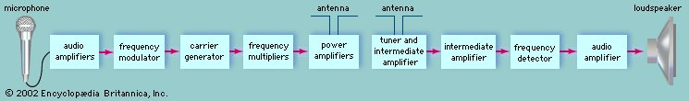
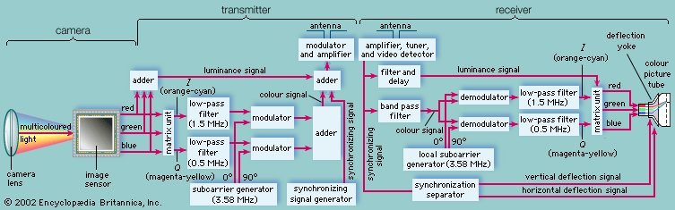
Figure 4.4 a and b: Block Diagram of Colour TV Transmitter

A PAL colour TV transmitter consists of following three main sections.
1. Production of Luminance (Y) and Chrominance (U and V) signals
2. PAL encoder
3. Video and Audio modulators and transmitting antenna Production of Luminance (Y) and Chrominance (U and V) signals: Colour camera tube produces R, G and B voltages pertaining to the intensity of red, green and blue colours respectively in pixels.
The luminance signal Y is obtained by a resistive matrix, using grassman's law. Y=0.3R+0.59G+0.11B. For colour section Y is inverted colours R&B obtained from the colour camera tubes are added to it to get (R-Y) and (B-Y) colour difference signal. These signals are weighted by two resistive matrix network which gives U & V signals as U=0.493 (B-Y) & V=0.877(R-Y) PAL encoder: PAL switch which operates electronically at 7812.5Hz with the help of bistable multivibrator and feeds the subcarrier to balanced modulator with phase difference of +900 on one line and -900 on the next line. The PAL encoder consists of a sub carrier generator and two balanced modulator with filters to produce modulated subcarrier signal. These signals are added vertically to give Chroma signal (C). Then Chroma signal is mixed with Y signal along with sync. And blanking pulses to produce Colour Composite Video Signal (CCVS). Video and Audio modulators and transmitting antenna: CCVS amplitude modulates the main video carrier. It is followed by a sharp VSB filter to attenuate the LSB to give AMVSB signal for transmitter. Audio signal modulates separate carrier. This modulation is FM type. AMVSB video signal along with audio signal passes to the transmitting antenna through Diplexer Bridge which is a wheat-stone's bridge.

ASSIGNMENT 4
    - Differentiate between radio and television broadcasting
    - Why does the modulated signal in radio broadcasting has to be amplified before being transmitted
    - What do you understand by PAL system?
QUIZ 4:
- Apart from PAL TV colour system, list and explain any two other TV colour systems being used around the worlds
- Explain how the colour signal is being generated?

CHAPTER 5.0
RADIO & TELEVISION RECEPTION

RADIO RECEIVER
The radio receivers installed in the commercial AM/FM radio stations, are very important due to their social impact.
There have been radio receivers installed in the commercial AM/FM radio stations since September 1995. These receivers were equipped with special audio control systems designed by CIRES to switch over the standard audio program from the radio stations to a 60-sec prerecorded message of early warning. This message consists of a clearly identifiable special tone and the statement “seismic alert, seismic alert” in Spanish (alerta sísmica, alerta sísmica). This statement is automatically broadcast without the intervention of human operators. Earlier, in some stations a cassette had to be inserted into the broadcast equipment in order to play the alert message, resulting in the loss of valuable time. The warning message does not contain technical information, specific guidance of protective actions, or a description of the potential dangers or severity of the earthquake.

Over the years, many different types of radio receiver have been designed. The different types of receiver have arisen out of the needs of the day and the technology available.
Early radio receivers had poor performance compared to those used today. Nowadays with advanced techniques like digital signal processing, and high performance semiconductors and other components, very high performance radios are commonplace.

Radio receiver applications
Today, there are many different applications for radio receivers. Everything from the more traditional broadcast radio receiver to professional communications receivers. In addition to this, the explosion in cellular and wireless communications has meant that there are very many different radio receivers needed for different applications.
Each application has its own requirements and as a result, many different types of radio receiver are needed.
Some radio receiver types are much simpler than others, whereas some have higher levels of performance and are not confined by space as much.
In view of the huge difference in requirements and performance levels needed, many different types of radio can be seen these days.

Radio receiver types
Many of the different radio receiver types have been around for many years. The component technology, and in particular semiconductor technology has surged forwards enabling much higher levels of performance to be achieved in a much smaller space.
There is a number of different types of radio:
- Tuned radio frequency, TRF : This type of radio receiver was one of the first that was used. The very first radio receivers of this type simply consisted of a tuned circuit and a detector. Crystal sets were early forms of TRF radios.
Later amplifiers were added to boost the signal level, both at the radio frequencies and audio frequencies. There were several problems with this form of receiver. The main one was the lack of selectivity. Gain / sensitivity was also in use.

- Regenerative receiver: The regenerative radio receiver significantly improved the levels of gain and selectivity obtainable. It used positive feedback and ran at the point just before oscillation occurred. In this way a significant multiplication in the level of "Q" of the tuned circuit was gained. Also major improvements in gain were obtained this way.

- Super regenerative receiver: The super regenerative radio receiver takes the concept of regeneration a stage further. Using a second lower frequency oscillation within the same stage, this second oscillation quenches or interrupts the oscillation of the main regeneration – typically at frequencies of around 25 kHz or so above the audio range. In this way the main regeneration can be run so that the stage is effectively in oscillation where it provides very much higher levels of gain. Using the second quench oscillation, the effects of running the stage in oscillation are not apparent to the listener, although it does emit spurious signals which can cause interference locally. Gain levels of over a million are not uncommon using this type of radio receiver.

- Superheterodyne receiver: The superheterodyne form of radio receiver was developed to provide additional levels of selectivity. It uses the heterodyne or mixing process to convert signals done to a fixed intermediate frequency. Changing the frequency of the local oscillator effectively tunes the radio. This type of radio format converts the signal directly down to the baseband frequency. Initially it was used for AM, Morse (CW) and SSB transmissions, but now it is widely used for digital communications where IQ demodulators are used to take advantage of the variety of phase shift keying, PSK, and quadrature amplitude modulation, QAM signals.

Many of these different types of radio receiver are in widespread use today. Each type of radio has its own characteristics that lend its use to particular applications.

MONOCHROME TELEVISION RECEIVER
According to the Block Diagram of Black and White Television Sets In a typical black and white television receiver, the signal from the antenna is fed to the tuner. Two channel selector switches – one for the VHF (very-high-frequency) channels 2-13 and the other for the UHF (ultra-high-frequency) channels 14-69 -are used. They connect circuits that are tuned to the desired channels and, also discriminate against signals from undesired channels. These circuits also form part of an amplifier, designed to add as little snow to the signal as possible.
The amplified signals from the desired channel are then passed to the mixer, which transposes all the signal frequencies in the channel to different values, called intermediate frequencies. The output of the tuner consists of all the signals in the desired channel, but the intermediate channel is fixed in the frequency band from 41 to 47 MHz, no matter what channel is tuned in. This is kind of like those cable television "set top" converters, that, regardless of what channel you’re watching, always convert it to "channel 3" for your TV set.
From the tuner, the 41-47 MHz channel with all picture and sound information present is passed successively through several additional amplifiers (from two to four intermediate frequency, or IF, amplifiers), which provide most of the amplification in the receiver. Their amplification is automatically adjusted, being maximum on a weak signal and less on a strong signal. So far the receiver handles the signals in the channel just like they would be received from the transmitter, except for the shift to intermediate frequencies and the amplification.
The next stage is the video detector, which removes the high frequency carrier signal and recovers the video signal. The detector also reproduces (at a lower frequency) the sound carrier and its frequency variations. The sound signal is then separated from the picture signal and passes through a frequency detector, which recovers the audio signal. This signal is amplified further and fed to the loudspeaker, where it re-creates the accompanying sound. The picture signal from the video detector is used in the normal fashion for display on the CRT of the television receiver.
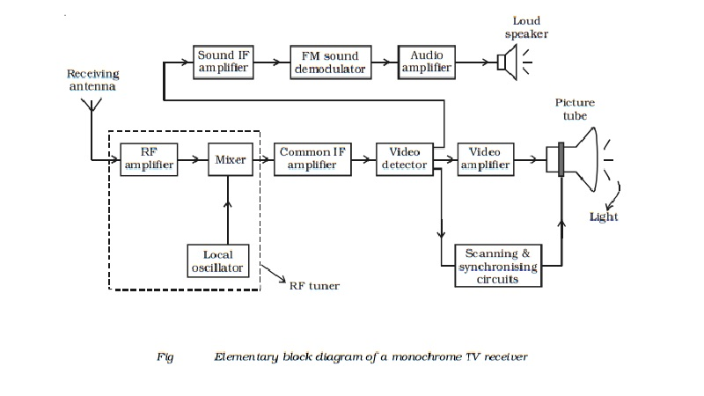
Figure 5.1
The simplified block diagram of a black and white TV receiver is shown in Fig 5.1. The receiving antenna intercepts radiated RF signals and the tuner selects the desired channel frequency band. The antenna provides RF picture and sound signals for the RF amplifier stage. The RF amplifier stage is then coupled into the mixer stage. The mixture is connected to the local oscillator. The RF audio and video signals are heterodyned into intermediate frequency by the mixer and local oscillator. The RF amplifier, mixer and local oscillator stages are combinely called as the RF tuner. The output signal from the tuner circuit is amplified by using a common IF amplifier. Then the video and audio components are separated by a detector. The sound signals are detected from FM waves, amplified and then fed into the loud speaker, which reproduce the sound.
The video components are first passed into a detector which separates the picture signal from the synchronising pulses. The line synchronising pulses and the frame synchronising pulses are fed into the horizontal and vertical deflector plates of the picture tube. The blanking pulses are given to the control grid of the electron gun of the picture tube. The picture signals are applied to the filament of the electron gun of the picture tube. According to the variations of potential in the picture, electrons are emitted from the electron gun. Thus, the intensity of the fluorescent screen of the picture tube is in accordance with the variation of potential in the picture and the picture is reproduced.
ASSIGNMENT 5
Sketch the block diagram of a monochrome TV receiver and explain the functions of the mixer, local oscillator and video detector
QUIZ 5
Differentiate between radio transmitter and radio receiver
CHAPTER 6.0

TELEGRAPHY AND TELEPHONES

In the era of electrical communications, from its beginnings in the 1830s through to the end of analogue technology. The electric telegraph soon became an essential and visible business tool with its network of poles and wires, but it is argued that, as each system was supplanted by the next, the evidence of its existence soon disappeared. The telegraph equipment manufacturers have not necessarily survived either, and a case study of the history of Reid Brothers, Engineers Ltd is given by way of example. Little evidence of the electric telegraph’s built environment now remains in Britain. When the telephone was introduced in Britain in the late 1870s, it was seen by the Post Office as a threat to its monopoly control of the inland electric telegraph system, and a court action which the Post Office won in 1880 had a retarding effect on the development of a national telephone network. The telephone exchange buildings and trunk lines became more prominent than those of the telegraph, but technological improvements caused the open-wire pole routes gradually to disappear. The Post Office created a characteristic architectural style for its buildings, but the independent telephone undertaking in Kingston upon Hull remained distinctively different in this respect. Wireless telegraphy and radio telephony imposed their own new look on the countryside, but this too has disappeared in turn. The author concludes that selected preservation of the buildings and artefacts of superseded telecommunications systems is important for a full understanding of the technology.
Telegraphy is the long-distance transmission of textual messages where the sender uses symbolic codes, known to the recipient, rather than a physical exchange of an object bearing the message. The earliest true telegraph put into widespread use was the optical telegraph of Claude Chappe, invented in the late 18th century. The system was extensively used in France, and European countries controlled by France, during the Napoleonic era. The electric telegraph started to replace the optical telegraph in the mid-19th century. It was first taken up in Britain in the form of the Cooke and Wheatstone telegraph, initially used mostly as an aid to railway signalling. This was quickly followed by a different system developed in the United States by Samuel Morse. The electric telegraph was slower to develop in France due to the established optical telegraph system, but an electrical telegraph was put into use with a code compatible with the Chappe optical telegraph. The Morse system was adopted as the international standard in 1865, using a modified Morse code developed in Germany.

Telephone
Today's telephone system, in which electric current is used to transmit the human voice, is derived from a principle discovered by C. G. Page of the United States in 1837. Based on this principle, in 1854, the Frenchman C. Bourseul revealed his concept of the use of vibrations generated on flexible diaphragms by the voice. Moreover, based on this concept, in 1861, J. P. Reis of Germany conducted an experiment (in which voice was projected onto a thin sausage skin to produce vibrations, and the vibrations were converted into changes in electric current), taking a closer step toward the realization of the telephone.
The invention of a practical telephone was achieved in March 1876 by the American A. G. Bell. Featuring a diaphragm and a bar magnet in a coil of insulated wire, his telephone had a mechanism in which changes in electric current were generated according to sound wave vibration, and the generated electric current change was transmitted to convey the voice. Regarding this invention, an event occurred that still holds a special place in the history of the telephone. On February 14, 1876, the day that Bell filed his patent application for the invention, a similar application was also filed by E. Gray, only two hours after Bell's. Bell exhibited his telephone at the Philadelphia International Exposition of 1876, giving a telephone demonstration.

Phonograph

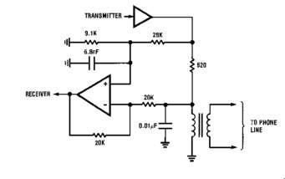 telephone circuit

ASSIGNMENT 6
    - List and describe any three modern technologies used for sending text messages and communicating (including audio and video
    - List five manufacturers of modern communication devices
QUIZ 6
- Describe the principle of telephone system
- Mention and explain any five modern applications use for audio/video conferencing

CHAPTER 7

CLASSIFICATIONS OF RADIO FREQUENCIES
Radio waves are a type of electromagnetic radiation best-known for their use in communication technologies, such as television, mobile phones and radios. These devices receive radio waves and convert them to mechanical vibrations in the speaker to create sound waves.
The radio-frequency spectrum is a relatively small part of the electromagnetic (EM) spectrum. The EM spectrum is generally divided into seven regions in order of decreasing wavelength and increasing energy and frequency, according to the University of Rochester. The common designations are
- Radio waves
- Microwaves
- Infrared (IR)
- Visible light
- Ultraviolet (UV)
- X-rays and
- Gamma-rays

Radio waves have the longest wavelengths in the EM spectrum, ranging from about 0.04 inches (1 millimeter) to more than 62 miles (100 kilometers). They also have the lowest frequencies, from about 3,000 cycles per second, or 3 kilohertz, up to about 300 billion hertz, or 300 gigahertz.

The radio spectrum is a limited resource and is often compared to farmland. Just as farmers must organize their land to achieve the best harvest regarding quantity and variety, the radio spectrum must be split among users in the most efficient way.

Radio Frequencies of Interest
The radio spectrum—i.e., the radio-communication portion of the electromagnetic spectrum—extends from the VLF (very-low-frequency) band to the EHF (extremely-high-frequency) band, i.e., from about 3 kHz to 300 GHz. The other bands that separate VLF from EHF are
- LF (low frequency),
- MF (medium frequency),
- HF (high frequency),
- VHF (very high frequency),
- UHF (ultra high frequency), and
- SHF (super high frequency).
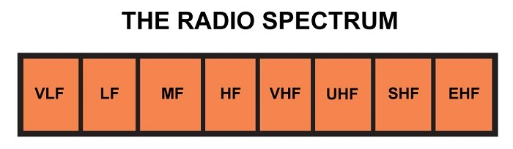

These divisions are rather arbitrary and there is no dire need to know the exact frequency ranges. It would be better to simply give some examples of wireless-communication categories that are found in different portions of the spectrum, because this will help us gain an intuitive awareness of which frequency ranges are more appropriate for certain types of systems.
- AM radio communication uses the MF band; more specifically, the carrier frequencies vary from 540 to 1600 kHz. We know from experience that AM radio has good range and is resistant to physical interference from buildings, but AM does not have a reputation for excellent audio quality.
- FM radio communication uses the VHF band, with carrier frequencies from 88.1 to 108.1 MHz. The allowable deviation from the carrier is significantly higher in FM than in AM, which means that FM signals can transfer more information per unit time than AM signals. (Keep in mind that in this context “AM” and “FM” refer to standardized categories of radio transmission, not to amplitude and frequency modulation in general.)
- Digital communication systems such as Bluetooth and some of the 802.11 protocols operate in the low-gigahertz range, more specifically, at frequencies near 2.4 GHz. These are generally short-range systems, but they offer reliable communication and the high carrier frequency enables high data rates. These protocols can be used by devices that are very small yet provide relatively long battery life.
- Satellites—obviously representing an application in which long range is important—tend to operate at very high frequencies. At the lower end of this range (1–2 GHz) is the L band, which is used by GPS satellites. The C band (4–8 GHz) is used, for example, by satellite TV networks. The Ku band, which extends to the impressive frequency of 18 GHz, is employed for various satellite applications and is an important part of the communication equipment on the International Space Station.

Summary
- The electromagnetic spectrum refers to the range of EMR frequencies present in the universe. This spectrum is divided and subdivided into different frequency bands.
- The general section that is relevant to RF communication is referred to as the radio spectrum, and the radio spectrum is divided into eight bands.
- Interference among separate radio systems can be avoided by using different carrier frequencies.
- Bandwidth and propagation requirements influence the choice of carrier frequency, and in turn the carrier frequency influences the characteristics of a particular system.
- The highest-frequency band within the radio spectrum represents the transition from signals that behave more like radio waves to signals that behave more like optical waves.

ASSIGNMENT 7
Explain any three of the seven EM spectrum, state their frequencies, wavelengths, applications and negative effects/challenges faced in using them

QUIZ 7
Classify the radio frequency spectrum and state the area of applications of each

CHAPTER 8
ANTENNAS/AERIALS

The Curiosity of Long-Distance Communication
Have you ever been in the car listening to a radio station from hundreds of miles away? Have you ever wondered how you can talk to someone thousands of miles away on the telephone? This is all made possible using antennas. An antenna is a device made of conductive metal (metal that conducts electricity) that sends and/or receives electromagnetic radio waves.Electromagnetic radio waves are waves of light within a specific frequency (3 Kilohertz to 300 gigahertz) that are invisible to the human eye, and are utilized for long distance communication. These waves are intercepted by your antenna, which properly ''displays'' the sound within the wave.

How does an Antenna Function?
Antennas have many different uses, from WiFi to radio , but they all work in fundamentally the same way: a transmitter sends a signal, which is intercepted by a receiver.
Listening to music inside a vehicle starts with a radio station with a large radio transmitter. The transmitter functions by taking audio, such as music, and turning the noise into an electrical current. The current then flows vertically along a radio tower to the top where it makes electrons, charged particles inside of an atom, bounce around. This creates electromagnetic radio waves and sends them hundreds of miles. Electrical equipment broadcasts the electrical current at a specified frequency -- let's say 101.5 megahertz.
These waves are then received by radio receivers. Radio receivers have antennas that are connected to tuners. The tuners look for a specific frequency of radio waves. If you tell the tuner to look at 101.5, the tuner receives the incoming radio waves and the amplifier takes over. The amplifier boosts the sound so you can hear the music inside your car.

So, here’s how you go about choosing the right antenna:
- Determine which channels are available where you live
- Choose which channels you want to watch
- Check the rules on antenna installation where you live
- Figure out which type of antenna you need
- Select the antenna

BASIC ANTENNA TYPES
The following discussion of antenna types assumes an “adequate´ ground plane is present.

1/4 WAVE
A single radiating element approximately 1/4 wavelength long. Directivity 2.2 dBi, 0 dBd.

LOADED 1/4 WAVE
The loaded 1/4 wave antenna looks electrically like a 1/4 wave antenna but the loading allows the antenna to be physically smaller than a 1/4 wave antenna. Quite often this is implemented by placing a loading coil at the base of the antenna. Gain depends upon the amount of loading used. Directivity 2.2 dBi, 0 dBd.

1/2 WAVE
A single radiating element 1/2 wavelength long. Directivity 3.8 dBi, 1.6 dBd. A special design is the end fed 1/2 wave.

5/8 WAVE
A single radiating element 5/8 wavelength long. Directivity 5.2 dBi, 3.0 dBd.

COLLINEAR
Two or three radiating elements separated by phasing coils for increased gain. Four common styles are:
1) 5/8 over 1/4: The top element is 5/8 wave and the bottom element is 1/4 wave. Directivity 5.4 dBi, 3.2 dBd.
2) 5/8 over 1/2: The top element is 5/8 wave and the bottom is 1/2 wave. Directivity 5.6 dBi, 3.4 dBd.
3) 5/8 over 5/8 over 1/4: The top 2 elements are 5/8 wave and the bottom element is 1/4 wave. Directivity 7.2 dBi, 5.0 dBd.
4) 5/8 over 5/8 over 1/2: The top 2 elements are 5/8 wave and the bottom element is 1/2 wave. Directivity 7.6 dBi, 5.4 dBd.

Using more than three radiating elements in a base-fed collinear configuration does not significantly increase gain. The majority of the energy is radiated by the elements close to the feed point of the collinear antenna so there is only a small amount of energy left to be radiated by the elements which are farther away from the feed point.
Please note the directivity is given above for common antenna configurations. Gain depends upon the electrical efficiency of the antenna. Here is where the real difference between antenna manufacturers is seen. If you cut corners in building an antenna, the gain may be significantly lower than the directivity. Larsen uses low-loss materials to minimize the difference between the gain and the directivity in our antennas.

WHIP
The vertical portion of the antenna assembly acting as the radiator of the radio frequency

GPS
Active GPS antennas include an amplifier circuit in order to provide better reception of the satellite signal. This active stage generally includes a low noise amplifier and a power amplifier.
Combi GPS/Cellular structures include several antennas in one radome to allow reception and transmission in different frequency bands.

DIPOLE
An antenna – usually 1/2 wavelength long – split at the exact center for connection to a feed line. Dipoles are the most common wire antenna. Length is equal to 1/2 of the wavelength for the frequency of operation. Fed by coaxial cable.
Sleeve Dipoles are realized by the addition of a metallic tube on a coaxial structure.
Printed Dipoles have a radiation structure supported by a printed circuit.

EMBEDDED OMNI
Embedded omni antennas are generally integrated on a base for applications such as access points. This structure could be externally mounted (ex: sleeve dipole) or directly integrated on the PC board of the system (ex: printed dipole).

YAGI
A directional, gain antenna utilizing one or more parasitic elements. A yagi consists of a boom supporting a series of elements which are typically aluminum rods.

PANEL
Single Patch describes an elementary source obtained by means of a metallic strip printed on a microwave substrate. These antennas are included in the radiating slot category.
Patch Arrays are a combination of several elementary patches. By adjusting the phase and magnitude of the power provided to each element, numerous forms of beamwidth (electric tilt, sectoral, directional . . .) can be obtained.
Sectoral antennas can be depicted like a directive antenna with a beamwidth greater than 45°. A 1 dB beamwidth is generally defined for this kind of radiating structure.

OMNI CEILING MOUNT
Omni ceiling mount antennas are used for the propagation of data in an in-building environment. In order to provide good coverage, these antennas are vertically polarized and present an omnidirectional pattern in the horizontal plane and a dipolar pattern in the vertical plane.

PARABOLIC
An antenna consisting of a parabolic reflector and a radiating or receiving element at or near its focus. Solid Parabolics utilize a dish-like reflector to focus radio energy of a specific range of frequencies on a tuned element. Grid Parabolics employ an open-frame grid as a reflector, rather than a solid one. The grid spacing is sufficiently small to ensure waves of the desired frequency cannot pass through, and are hence reflected back toward the driven element.

PULSE-LARSEN ANTENNA TYPES
Mobile: Collinear, Whip, Low Profile, Active GPS, Combi GPS/Cellular
Portable: Whip, Helical, End Fed Half Wave, Sleeve, Half Wave Dipole, Embedded Omni, Printed Dipole
Base Station: Whip, Collinear, Yagi, Panel, In-building Sectoral, Omni-ceiling Mount

MOBILE ANTENNA PLACEMENT
Correct antenna placement is critical to the performance of an antenna. An antenna mounted on the roof of a car will function better than the same antenna installed on the hood or trunk. Knowledge of the vehicle may also be an important factor in determining what type of antenna to use. Do not install a glass mount antenna on the rear window of a vehicle in which metal has been used to reduce ultraviolet light. The metal tinting will work as a shield and not allow signals to pass through the glass.

SOME ANTENNA BASIC CONCEPTS/TERMS

WAVELENGTH

We often refer to antenna size relative to wavelength. For example: a 1/2 wave dipole is approximately half a wavelength long. Wavelength is the distance a radio wave travels during one cycle. The formula for wavelength is:
$$λ=\frac{C}{f}$$
Where:
λ is the wavelength expressed in units of length, typically meters, feet or inches
c is the speed of light (11,802,877,050 inches/second)
f is the frequency
For example: wavelength in air at 825 MHz is 11.803 X 109 in./sec = 14.307 in.
825 x 106 cycles/sec
Note: The physical length of a half-wave dipole is slightly less than half a wavelength due to end effect. The speed of propagation in coaxial cable is slower than in air, so the wavelength in the cable is shorter. The velocity of propagation of electromagnetic waves in coax is usually given as a percentage of free space velocity, and is different for different types of coax.

IMPEDANCE MATCHING
For efficient transfer of energy, the impedance of the radio, the antenna and the transmission line connecting the radio to the antenna must be the same. Radios typically are designed for 50 Ohms impedance, and the coaxial cables (transmission lines) used with them also have 50 Ohms impedance. Efficient antenna configurations often have an impedance other than 50 Ohms. Some sort of impedance matching circuit is then required to transform the antenna impedance to 50 Ohms. Larsen antennas come with the necessary impedance matching circuitry as part of the antenna. We use low-loss components in our matching circuits to provide the maximum transfer of energy between the transmission line and the antenna.

VSWR AND REFLECTED POWER
Voltage Standing Wave Ratio (VSWR) is an indication of the quality of the impedance match. VSWR is often abbreviated as SWR. A high VSWR is an indication the signal is reflected prior to being radiated by the antenna. VSWR and reflected power are different ways of measuring and expressing the same thing.
A VSWR of 2.0:1 or less is often considered acceptable. Most commercial antennas are specified to be 1.5:1 or less over some bandwidth. Based on a 100 watt radio, a 1.5:1 VSWR equates to a forward power of 96 watts and a reflected power of 4 watts, or the reflected power is 4.2% of the forward power.

BANDWIDTH
Bandwidth can be defined in terms of radiation patterns or VSWR/reflected power. The definition used is based on VSWR. Bandwidth is often expressed in terms of percent bandwidth, because the percent bandwidth is constant relative to frequency. If bandwidth is expressed in absolute units of frequency, for example MHz, the bandwidth is then different depending upon whether the frequencies in question are near 150 MHz, 450 MHz or 825 MHz.
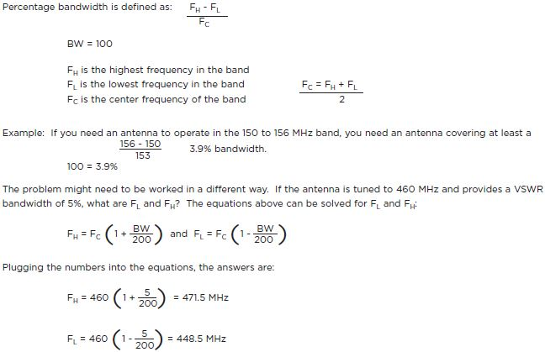

DECIBELS
Decibels (dB) are the accepted method of describing a gain or loss relationship in a communication system. The beauty of dB is they may be added and subtracted. A decibel relationship (for power) is calculated using the following formula.
dB = 10 log Power A
Power B
“A´ might be the power applied to the connector on an antenna, the input terminal of an amplifier or one end of a transmission line. “B´ might be the power arriving at the opposite end of the transmission line, the amplifier output or the peak power in the main lobe of radiated energy from an antenna. If “A´ is larger than “B´, the result will be a positive number or gain. If “A´ is smaller than “B´, the result will be a negative number or loss.
Example:
At 1700 MHz, one fourth of the power applied to one end of a coax cable arrives at the other end. What is the cable loss in dB?
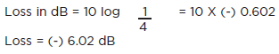
In the above case, taking the log of 1/4 (0.25) automatically results in a minus sign, which signifies negative gain or loss.
It is convenient to remember these simple dB values which are handy when approximating gain and loss:
Power Gain Power Loss
3 dB = 2X power – 3 dB = 1/2 power
6 dB = 4X power – 6 dB = 1/4 power
10 dB = 10X power -10 dB = 1/10 power
20 dB = 100X power -20 dB = 1/100 power
In the case of antennas, passive structures cannot generate power. dB is used to describe the ability of these structures to focus energy in a part of space.

DIRECTIVITY AND GAIN
Directivity is the ability of an antenna to focus energy in a particular direction when transmitting or to receive energy better from a particular direction when receiving. There is a relationship between gain and directivity. We see the phenomena of increased directivity when comparing a light bulb to a spotlight. A 100-watt spotlight will provide more light in a particular direction than a 100-watt light bulb and less light in other directions. We could say the spotlight has more “directivity´ than the light bulb. The spotlight is comparable to an antenna with increased directivity. Gain is the practical value of the directivity. The relation between gain and directivity includes a new parameter (η) which describes the efficiency of the antenna.
G = η • D
For example an antenna with 3 dB of directivity and 50% of efficiency will have a gain of 0 dB.

GAIN MEASUREMENT
One method of measuring gain is to compare the antenna under test against a known standard antenna. This is known as a gain transfer technique. At lower frequencies, it is convenient to use a 1/2-wave dipole as the standard. At higher frequencies, it is common to use a calibrated gain horn as a gain standard with gain typically expressed in dBi.
Another method for measuring gain is the 3-antenna method. Transmitted and received powers at the antenna terminal are measured between three arbitrary antennas at a known fixed distance. The Friis transmission formula is used to develop three equations and three unknowns. The equations are solved to find the gain expressed in dBi of all three antennas.
Pulse-Larsen uses both methods for measurement of gain. The method is selected based on antenna type, frequency and customer requirement.
Use the following conversion factor to convert between dBd and dBi: 0 dBd = 2.15 dBi.
Example: 3.6 dBd + 2.15 dB = 5.75 dBi

RADIATION PATTERNS
Radiation or antenna pattern describes the relative strength of the radiated field in various directions from the antenna at a constant distance. The radiation pattern is a “reception pattern´ as well, since it also describes the receiving properties of the antenna. The radiation pattern is three-dimensional, but it is difficult to display the three-dimensional radiation pattern in a meaningful manner. It is also time-consuming to measure a three-dimensional radiation pattern. Often radiation patterns measured are a slice of the three-dimensional pattern, resulting in a two-dimensional radiation pattern which can be displayed easily on a screen or piece of paper. These pattern measurements are presented in either a rectangular or a polar format.
ASSIGNMENT 8
  - Explain why antenna is a bidirectional transducer
  - What are the conditions required for choosing antenna
  - Sketch any two types of antenna and explain how they function?

QUIZ 8
- Explain the following terms: (a) Decibels (b) Directivity (c) Radiation patterns (d) Bandwidth and (e) Wavelength

CHAPTER 9
PROPAGATION OF RADIO WAVES
Radio propagation is the way radio waves travel or propagate when they are transmitted from one point to another and affected by the medium in which they travel and in particular the way they propagate around the Earth in various parts of the atmosphere.

Factors affecting radio propagation
There are many factors that affect the way in which radio signals or radio waves propagate. These are determined by the medium through which the radio waves travel and the various objects that may appear in the path. The properties of the path by which the radio signals will propagate governs the level and quality of the received signal.
Reflection, refraction and diffraction may occur. The resultant radio signal may also be a combination of several signals that have travelled by different paths. These may add together or subtract from one another, and in addition to this the signals travelling via different paths may be delayed causing distorting of the resultant signal. It is therefore very important to know the likely radio propagation characteristics that are likely to prevail.
Radio signals can travel over vast distances. However radio signals are affected by the medium in which they travel and this can affect the radio propagation or RF propagation and the distances over which the signals can propagate. Some radio signals can travel or propagate around the globe, whereas other radio signals may only propagate over much shorter distances.
Radio propagation, or the way in which radio signals travel can be an interesting topic to study. RF propagation is a particularly important topic for any radio communications system. The radio propagation will depend on many factors, and the choice of the radio frequency will determine many aspects of radio propagation for the radio communications system.
Radio wave propagation is not constrained by any physical conductor or waveguide. This makes radio ideal for mobile communications, satellite and deep-space communications, broadcast communications, and other applications in which the laying of physical connections may be impossible or very costly. On the other hand, unlike guided channels such as wire or optical fibre, the medium through which radio waves propagate is highly variable, being subject to diurnal, annual, and solar changes in the ionosphere, variations in the density of water droplets in the troposphere, varying moisture gradients, and diverse sources of reflection and diffraction.
The range of a radio communications link is defined as the farthest distance that the receiver can be from the transmitter and still maintain a sufficiently high signal-to-noise ratio (SNR) for reliable signal reception. The received SNR is degraded by a combination of two factors: beam divergence loss and atmospheric attenuation. Beam divergence loss is caused by the geometric spreading of the electromagnetic field as it travels through space. As the original signal power is spread over a constantly growing area, only a fraction of the transmitted energy reaches a receiving antenna. For an omnidirectional radiating transmitter, which broadcasts its signal as an expanding spherical wave, beam divergence causes the received field strength to decrease by a factor of 1/r², where r is the radius of the circle, or the distance between transmitter and receiver.

Types of radio propagation
There are a number of categories into which different types of RF propagation can be placed. These relate to the effects of the media through which the signals propagate.
- Free space propagation: Here the radio waves travel in free space, or away from other objects which influence the way in which they travel. It is only the distance from the source which affects the way in which the signal strength reduces. This type of radio propagation is encountered with radio communications systems including satellites where the signals travel up to the satellite from the ground and back down again. Typically there is little influence from elements such as the atmosphere, etc.
- Ground wave propagation: When signals travel via the ground wave they are modified by the ground or terrain over which they travel. They also tend to follow the Earth's curvature. Signals heard on the medium wave band during the day use this form of RF propagation.
- Ionospheric propagation: Here the radio signals are modified and influenced by a region high in the earth's atmosphere known as the ionosphere. This form of radio propagation is used by radio communications systems that transmit on the HF or short wave bands. Using this form of propagation, stations may be heard from the other side of the globe dependent upon many factors including the radio frequencies used, the time of day, and a variety of other factors.
- Tropospheric propagation: Here the signals are influenced by the variations of refractive index in the troposphere just above the earth's surface. Tropospheric radio propagation is often the means by which signals at VHF and above are heard over extended distances.

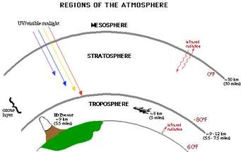

In addition to these main categories, radio signals may also be affected in slightly different ways. Sometimes these may be considered as sub-categories, or they may be quite interesting on their own.
Some of these other types of niche forms of radio propagation include:
- Sporadic E: This form of propagation is often heard on the VHF FM band, typically in summer and it can cause disruption to services as distant stations are heard.
- Meteor scatter communications: As the name indicates, this form of radio propagation uses the ionised trails left by meteors as they enter the earth’s atmosphere. When data is not required instantly, it is an ideal form of communications for distances around 1500km or so for commercial applications. Radio amateurs also use it, especially when meteor showers are present.
- Transequatorial propagation, TEP: Transequatorial propagation occurs under some distinct conditions and enables signals to propagate under circmstances when normal ionospheric propagation paths would not be anticipated.
- Near Vertical Incidence Skywave, NVIS: This form of propagation launches skywaves at a high angle and they are returned to Earth relatively close by. It provides local coverage in hilly terrain.
- Auroral backscatter: The aurora borealis (Northern Lights) and Aurora Australis (Southern Lights) are indicators of solar activity which can disrupt normal ionospheric propagation. This type of propagation is rarely used for commercial communications as it is not predictable but radio amateurs often take advantage of it.
- Moonbounce EME: When high power transmissions are directed towards the moon, feint reflections can be heard if the antennas have sufficient gain. This form of propagation can enable radio amateurs to communicate globally at frequencies of 140 MHz and above, effectively using the Moon as a giant reflector satellite.

In addition to these categories, many short range wireless or radio communications systems have RF propagation scenarios that do not fit neatly into these categories. Wi-Fi systems, for example, may be considered to have a form of free space radio propagation, but there will be will be very heavily modified because of multiple reflections, refractions and diffractions. Despite these complications it is still possible to generate rough guidelines and models for these radio propagation scenarios.

Ionospheric Layers: D, E, F, F1, F2, Regions
Within the ionosphere there are several different ionospheric regions which affect the propagation of radio signals in different ways - the D layer, E layer, F layer which splits into F1 and F2 layers all affect radio signals differently
The traditional view of the ionosphere indicates a number of distinct layers, each affecting radio communications in slightly different ways. Indeed, the early discoveries of the ionosphere indicated that a number of layers were present.
While this is a convenient way of picturing the structure of the ionosphere it is not exactly correct. Ionisation exists over the whole of the ionosphere, its level varying with altitude. The peaks in level may be considered as the different layers or possibly more correctly, regions. These regions are given letter designations: D, E, and F regions.
There is also a C region below the others, but the level of ionisation is so low that it does not have any effect radio signals and radio communications, and it is rarely mentioned.
The different layers or regions in the ionosphere have different characteristics and affect radio communications in different ways. There are also differences in the exact way they are created and sustained. In view of this it is worth taking a closer look at each one in detail and the way they vary over the complete day during light and darkness.

D Region
When a sky wave leaves the Earth's surface and travels upwards, the first region of interest that it reaches in the ionosphere is called the D layer or D region.
It is present at altitudes between about 60 and 90 kilometres and the radiation within it is only present during the day to an extent that affects radio waves noticeably. It is sustained by the radiation from the Sun and levels of ionisation fall rapidly at dusk when the source of radiation is removed.
The D layer is chiefly generated by the action of a form of radiation known as Lyman radiation which has a wavelength of 1215 Angstroms and ionises nitric oxide gas present in the atmosphere. Hard X-Rays also contribute to the ionisation, especially towards the peak of the solar cycle.
The D layer or D region mainly has the effect of absorbing or attenuating radio communications signals particularly in the LF and MF portions of the radio spectrum, its affect reducing with frequency. At night it has little effect on most radio communications signals although there is still a sufficient level of ionisation for it to refract VLF signals.
This region attenuates the signals as they pass through. The level of attenuation depends on the frequency. Low frequencies are attenuated more than higher ones. In fact it is found that the attenuation varies as the inverse square of the frequency, i.e. doubling the frequency reduces the level of attenuation by a factor of four. This means that low frequency signals are often prevented from reaching the higher regions, except at night when the region disappears.
The D region attenuates signals because the radio signals cause the free electrons in the region to vibrate. As they vibrate the electrons collide with molecules, and at each collision there is a small loss of energy. With countless millions of electrons vibrating, the amount of energy loss becomes noticeable and manifests itself as a reduction in the overall signal level. The amount of signal loss is dependent upon a number of factors: One is the number of gas molecules that are present. The greater the number of gas molecules, the higher the number of collisions and hence the higher the attenuation.
The level of ionisation is also very important. The higher the level of ionisation, the greater the number of electrons that vibrate and collide with molecules. The third main factor is the frequency of the signal. As the frequency increases, the wavelength of the vibration shortens, and the number of collisions between the free electrons and gas molecules decreases. As a result signals lower in the radio frequency spectrum are attenuated far more than those which are higher in frequency. Even so high frequency signals still suffer some reduction in signal strength.

E Region
The E region or E layer is above the D region. It exists at altitudes between about 100 and 125 kilometres. Instead of attenuating radio communications signals this layer chiefly refracts them, often to a degree where they are returned to earth. As such they appear to have been reflected by this layer. However this layer still acts as an attenuator to a certain degree.
At the altitude where the E layer or E region exists, the air density is very much less than it is for the D region. This means that when the free electrons are excited by radio signals and vibrate, far fewer collisions occur. As a result the way in which the E layer or E region acts is somewhat different. The electrons are again set in motion by the radio signal, but they tend to re-radiate it. As the signal is travelling in an area where the density of electrons is increasing, the further it progresses into the region, the signal is refracted away from the area of higher electron density. In the case of HF signals, this refraction is often sufficient to bend them back to earth. In effect it appears that the region has "reflected" the signal.
The tendency for this "reflection" is dependent upon the frequency and the angle of incidence. As the frequency increases, it is found that the amount of refraction decreases until a frequency is reached where the signals pass through the region and on to the next. Eventually a point is reached where the signal passes through the E layer on to the next layer above it.
Like the D region, the level of ionisation falls relatively quickly after dark as the electrons and ions re-combine and it virtually disappears at night. However the residual night time ionisation in the lower part of the E region causes some attenuation of signals in the lower portions of the HF part of the radio communications spectrum.
The ionisation in this region results from a number of types of radiation. Soft X-Rays produce much of the ionisation, although extreme ultra-violet (EUV) rays (very short wavelength ultra-violet light) also contribute. Broadly the radiation that produces ionisation in this region has wavelengths between about 10 and 100 Angstroms. The degree to which all of the constituents contribute depends upon the state of the Sun and the latitude at which the observations are made.

F Region
The most important region in the ionosphere for long distance HF radio communications is the F region. During the daytime when radiation is being received from the Sun, it often splits into two: the lower one being the F1 region and the higher one, the F2 region. Of these the F1 region is more of an inflection point in the electron density curve (seen above) and it generally only exists in the summer.
Typically the F1 layer is found at around an altitude of 300 kilometres with the F2 layer above it at around 400 kilometres. The combined F layer may then be centred around 250 to 300 kilometres. The altitude of the all the layers in the ionosphere layers varies considerably and the F layer varies the most. As a result the figures given should only be taken as a rough guide. Being the highest of the ionospheric regions it is greatly affected by the state of the Sun as well as other factors including the time of day, the year and so forth.
The F layer acts as a "reflector" of signals in the HF portion of the radio spectrum enabling world wide radio communications to be established. It is the main region associated with HF signal propagation.
The action of the F layer n radio signals is the same as it is for the E layer, although with the air density being less, there are fewer collisions and les energy is lost. As a result, signals being reflected by the F layer, and in particular the F2 later are subject to low levels of attenuation. As a result, even low power signals can be heard at great distances.
Like the D and E layers the level of ionisation of the F region varies over the course of the day, falling at night as the radiation from the Sun disappears. However the level of ionisation remains much higher. The density of the gases is much lower and as a result the recombination of the ions and electrons takes place more slowly, at about a quarter of the rate that it occurs in the E region. As a result of this it still has an affect on radio signals at night being able to return many to Earth, although it has a reduced effect in some aspects.
The F region is at the highest region in the ionosphere and as such it experiences the most solar radiation. Much of the ionisation results from ultra-violet light in the middle of the spectrum as well as those portions of the spectrum with very short wavelengths. Typically the radiation that causes the ionisation is between the wavelengths of 100 and 1000 Angstroms, although extreme ultra-violet light is responsible for some ionisation in the lower areas of the F region.

Summary
There are many radio propagation scenarios in real life. Often, signals may travel by several means, radio waves travelling using one type of radio propagation interacting with another. However to build up an understanding of how a radio signal reaches a receiver, it is necessary to have a good understanding of all the possible methods of radio propagation. By understanding these, the interactions can be better understood along with the performance of any radio communications systems that are used.
The ionosphere is a continually changing area of the atmosphere. Extending from altitudes of around 60 kilometres to more than 400 kilometres it contains ions and free electrons. The free electrons affect the ways in which radio waves propagate in this region and they have a significant effect on HF radio communications.
The ionosphere can be categorized into a number of regions corresponding to peaks in the electron density. These regions are named the D, E, and F regions. In view of the fact that the radiation from the Sun is absorbed as it penetrates the atmosphere, different forms of radiation give rise to the ionisation in the different regions as outlined in the summary table below:

SUMMARY OF FORMS OF RADIATION CAUSING IONISATION IN THE IONOSPHERIC LAYERS OR REGIONS.
REGION | PRIMARY IONISING RADIATION FORMS
C | Cosmic
D | Lyman alpha, Hard X-Rays
E | Soft X-Rays and some Extreme Ultra-Violet
F1 | Extreme Ultra-violet, and some Ultra-Violet
F2 | Ultra-Violet

ASSIGNMENT 9
- What do you understand by radio wave propagation?
- Differentiate between sky wave and ground wave

QUIZ 9
- What are the different things happening at the stratosphere, troposphere and ionosphere regions of the atmosphere
- Which of the regions is further divided into D, E and F regions?
- Which region is the most important regio for long distance HF radio communications and why?
REFERENCES

    - A Textbook of Electrical Technology Volume IV - Electronic Devices and Circuits - B.L. Theraja
    - Wikipedia, the free encyclopedia
    - http://www.brainkart.com/article/Monochrome-TV-transmission_3016
    - https://www.tandfonline.com/author/Liffen%2C+John
    - Other sources from various internet sites

